DEMOCRATIC AND POPULAR ALGERIAN REPUBLIC
Abu Bekr-Belkaid University- Tlemcen
Faculty of Science
Department of Computer Science
End of studies thesis
For the graduation of the Master's degree in Computer Science
Option: Software engineering (G.L)
Theme
The development and implementation of a mobile transportation reservation application for the Wilaya of Tlemcen.
Directed by:
-Bouazzaoui Abdelwahab
-Merabet Abdelkader
Presented on 06/26/2024 in front of the jury composed of:
- Mme BEKKOUCHE AMINA | (President)
- Mme MEZIANE TANI SOUAD | (Framing)
- Mme KAZI TANI ADILA | (Examiner)

School year: 2023-2024

Dedication

∼ I dedicate this to my wonderful parents, who have always been there for me, before, during, and after this work. Your support and love have been my strength ∼
Acknowledgment
In the name of Allah, the Most Gracious, the Most Merciful. First and foremost, I express my deepest gratitude to Allah
I want to thank my parents first for being with me throughout this entire journey, providing unwavering support, love, and trust.
I extend my heartfelt gratitude to Mme MEZIANE, who was a true guide throughout this journey. she has demonstrated what a great teacher should be. Thank you for accompanying us during this work and for you. I wish you all the best in your life.
A huge thanks to the staff here, Mme BEKKOUCHE AMINA and Mme KAZI TANI ADILA
To my friends, who guided me and helped me from the start, thank you very much.

Table of content:
Table of content: III
Table of figures VI
List of Abbreviations: VIII
GENERAL INTRODUCTION 1
CHAPTER I: Study of the Existing 1
1. Introduction: 2
2. Similar Applications in Algeria: 2
2.1. DzairTransport: 2
2.1.1 Description 2
2.1.2 Features: 2
2.1.3 Limitations: 3
2.2. MAHATATI: 4
2.2.1 Description: 4
2.2.2 Features: 4
2.2.3 Limitations: 4
3. Similar application abroad: 6
3.1. Citymapper: 6
3.1.1 Description: 6
3.1.2 Features: 6
3.1.3 Limitations 6
3.2. SNCF Connect: 8
3.2.1 Description 8
3.2.2 Features: 8
3.2.3 Limitations: 8
4. Comparison table of existing applications: 10
5. Conclusion: 12
CHAPTER II: Needs Analysis and Design 13
1. Introduction: 14
2. Design 14
2.1. Definition of Roles: 15
2.1.1 Administrator: 15
Description: 15
Features 15
2.1.2 User: 15
Description 15
Features 15
2.1.3 Traveler: 15
Description: 15
Features: 15
2.2. Functional Requirements by Actor: 16
2.2.1 Administrator: 16
2.2.2 User: 17
2.2.3 Traveler: 18
2.3. Non-Functional Requirements: 18
2.4. Use Case Diagrams: 19
2.5. Sequence Diagrams: 22
2.6. Class Diagram: 26
3. Conclusion: 29
CHAPTER III: Realization and Development 30
1. Introduction: 31
2. Tools and technologies used: 32
2.1. Technologies used: 32
2.2. Tools used: 34
3. Concept Challenges: 36
3.1. Basics: 36
3.2. Algorithm: 36
4. Interfaces of the system: 39
4.1. Web part Interfaces: 39
4.2. Mobile Interfaces: 56
5. Conclusion: 65
GENERAL CONCLUSION 66
1. Perspective: 66

Table of figures
Fig 1. DzairTransport Interfaces‎[1]. 3
Fig 2. MAHATATI Interfaces‎[4] 5
Fig 3. Citymapper interfaces‎[6]. 7
Fig 4. SNCF Result Page‎[7]. 9
Fig 5. Comparison Table 11
Fig 6. User Use Case Diagram 20
Fig 7. Admin Use Case Diagram 21
Fig 8. Register Sequence Diagram 22
Fig 9. Search and select route Sequence Diagram 24
Fig 10. Search and reserve ticket Sequence Diagram 25
Fig 11. Class Diagram 28
Fig 12. GuiDZ Logo 31
Fig 13. Technologies Used 33
Fig 14. Tools Used 36
Fig 15. Login Page 39
Fig 16. Dashboard Overview Page 40
Fig 17. View Users Table 41
Fig 18. Users Reservations. 42
Fig 19. Create User Form 43
Fig 20. Create Admin Form 43
Fig 21. Cities Overview Page 44
Fig 22. View Cities Table 45
Fig 23. View City Info 45
Fig 24. City Information 46
Fig 25. Provenances 47
Fig 26. Streets 47
Fig 27. Stops 48
Fig 28. Hotspots 48
Fig 29. Routes Overview 49
Fig 30. View Routes Table 50
Fig 31. Line Information 51
Fig 32. Stops 52
Fig 33. Prices 53
Fig 34. Times 54
Fig 35. Scheduled And Rotation 54
Fig 36. Add New Route Interfaces 55
Figs 37. Authentication 56
Figs 38. Homepage 58
Figs 39. Search Result 59
Figs 40. Ticket Reservation 60
Fig 41. Itineraries 61
Figs 42. Account 63
Fig. 43. Notifications 64

List of Abbreviations:
UML | Unified Modeling Language
SOGRAL | The Algerian Bus Station Management Company
SNCF | The French National Railway Company
GPS | Global Positioning System
OTP | One-time Password
DOM | Document Object Model
UI | User Interface
RAPTOR | Round-Based Public Transit Routing

GENERAL INTRODUCTION

Locals and visitors alike find it very hard to move around the Wilaya of Tlemcen. People experience much difficulty in moving around efficiently, simply because there is not enough dependable information regarding public transportation.
The problem mainly being the lack of precise and updated details concerning buses, taxis, and trains. Without that information, planning your journeys to any desirable place is very difficult. Visitors especially suffer from this, as it can spoil their overall experience in the region.
Currently, there's no comprehensive central repository for this information. Travelers usually rely on word-of-mouth, outdated schedules, or inconsistent online resources. For a passenger, this makes the use of public transport less attractive and pushes people to take their own vehicles, which means more traffic and pollution. Another problem is a lack of real-time updates. People are not notified if there is a delay or a change in the route, which makes public transport unreliable.
To bridge the gap, we suggest an implementation of a comprehensive public transport information system that provides real-time updates, up-to-date route maps, and easily accessible schedules in mobile applications and websites. Support for multiple languages should also be a focus for tourists and non-locals. Better information about transport can save the time of residents and make Tlemcen more comfortable for tourists, thus developing the local economy. A reliable public transportation system is the foundation for the city’s growth.
This thesis is structured into three chapters:
❖ In the first chapter “State of the art” we analyze the functionalities of existing systems as well as their advantages and disadvantages, then we establish a comparative synthesis.
❖ In the second chapter “Design” we define the actors, the functional requirements and the non-functional requirements of our system, we then illustrate the UML diagrams (diagrams of use cases, sequences and classes).
❖ In the third chapter “Production” we present the different tools and technologies used throughout the development of our application.
❖ We close this thesis with a general conclusion and some perspectives.

CHAPTER I: Study of the Existing

- Introduction:
Traveling in an urban environment is necessary for all citizens in order to carry out many of their activities such as work for example. To get around, some people use their own vehicles, but most of the public relies on buses, taxis, and trains.
Today, there are several technological tools that help humans make decisions about which route to take, such as smartphones and navigation systems.
While most of us own smartphones and know how to use them for navigation, in our country, public transportation routes remain as ink on paper, as the move towards digitization has not yet been taken.
There are several mobile applications and websites that try to fix these issues both within Algeria and abroad, and we will present the most popular ones.

- Similar Applications in Algeria:

DzairTransport:
    - Description:
DzairTransport is a creative mobile application and web platform that was initiated to help you move in the streets of Algiers city as its seen in figure 1. This comprehensive platform helps you prepare your trips and make the most efficient use of the city's diverse public transportation options. Whether you are a daily commuter, a tourist exploring the city, or simply someone needing to get from point A to point B, DzairTransport has got you covered in Algiers‎[1]‎[2].

Features:
- Multi-Modal Transport Support: support for various modes of transportation is handy for new visitors or first-time travelers to the wilaya of Algiers.
- Trip Duration Estimate: it provides an estimate of the trip duration, helping users plan their journeys more effectively.
- Stations and Stops Display: the application displays all stations and stops along the route, offering comprehensive route details.

Limitations:
- Geographical Limitation: the application is limited to the wilaya of Algiers and does not cover other regions.
- Single Route Option: it does not offer multiple route choices for a given trip.
- Cost Calculation: the application does not calculate the cost of the trip.
- User Interface: the user interface is outdated and unintuitive, which can make the application difficult to use.

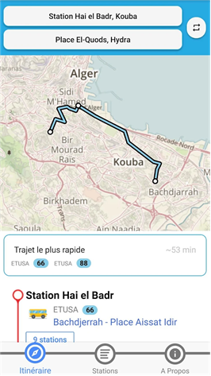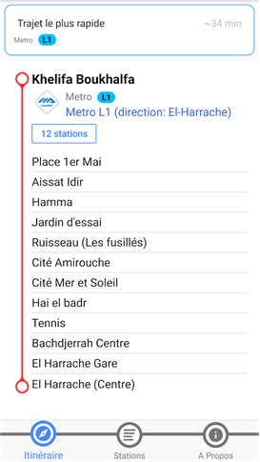
Fig 1. DzairTransport Interfaces‎[1].

MAHATATI:

Description:
MAHATATI‎[4]. is an application developed by SOGRAL‎[3]. Designed to enhance the public transportation experience in Algeria. The application offers a range of features as shown in figure 2 aimed at providing real-time information and facilitating travel planning for users.

Features:
- Departure Times in Real Time: you will never be in the dark about the departure time of different modes of transport. This helps you plan your journey effectively, and you are not made to wait.
- Route Description and Timetables: the application gives comprehensive trips, routes, and timetables. The application gives the exact stage where each bus is departing from. This function helps you to understand the progress of your trip and eases transportation through the network.
- Available Seats: check the number of available seats in real time against each departure. This feature is handy in ensuring that you get a seat on the trip you desire, adding on convenience and reducing uncertainty.
- Pricing: the application will help you know the fare prices to different destinations, depending on the chosen route. Additionally, it provides information about insured (guaranteed) and canceled departures to assist you in making informed decisions about your travel plans.

Limitations:
- Limited Urban and Inter-Municipal Routing: the application does not provide detailed itineraries within cities or between municipalities, which can limit its usefulness for travelers.
- Online Reservation Issues: sometimes, the online reservation system is not functional, preventing users from booking their tickets through the application.
- Incomplete Results: occasionally, the application does not display all relevant results accurately, which can be frustrating for users seeking comprehensive information.
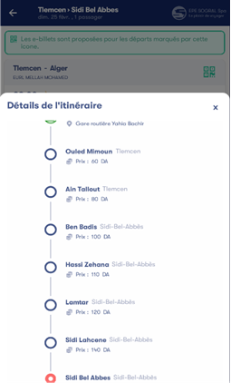
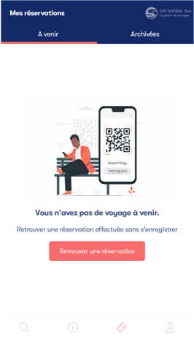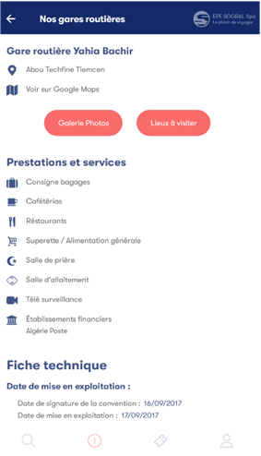
Fig 2. MAHATATI Interfaces‎[4]
- Similar application abroad:

Citymapper:

Description:
City Mapper‎[5]. is an application to find one's way around several public transports in many of the cities in Europe and North America. It supports buses, trains, metro systems, and so on, making it ideal for a person visiting for the first time or a commuter. The application offers a personalized navigation experience as seen in figure 3 by signing in and saving the home or workplace. It also lets you navigate saved routes with integrated assistance, which is designed for step-by-step guidance‎[6].

Features:
- Multi-City Support: The application supports many cities across Europe and North America for a large-scale user coverage.
- Multi-Transport Mode Integration: This application provides integration for various public transports such as buses, trains, and metro systems.
- User-Friendly Interface: The application boasts a user-friendly interface from the first time it's launched, making it accessible to everybody.
- Personalization: The ability to sign in and save home or workplace locations for easy access helps frequent users save time.
- Route Saving: Easy navigation of saved routes.
- Step-by-Step Navigation: The integrated assistance guides users step-by-step to their destinations as quickly as possible.
- Schedule Consultation: The application can be used to check the schedules for trains and other modes of transportation.
- Subscription Service: Offers a subscription that allows free travel within certain zones.

Limitations
- Regional Availability: While the application supports many cities, its usefulness is limited to users who visit these areas, and it may not be as helpful in less populated or rural areas.
- Subscription Restriction: The free travel offered by the subscription service is only within some particular zones, which may not cater to all the travel needs of the user.
- Dependence on Internet: Proper use of the application requires a robust internet connection, which may sometimes be a limitation in some areas with weak connectivity.
- Battery Usage: Continuous usage of step-by-step navigation may drain the battery of the mobile device.
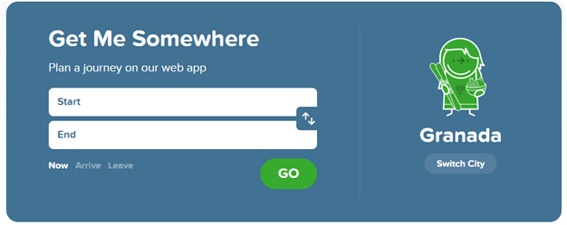
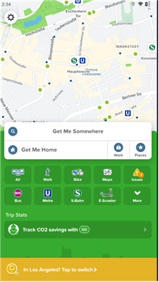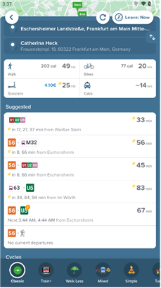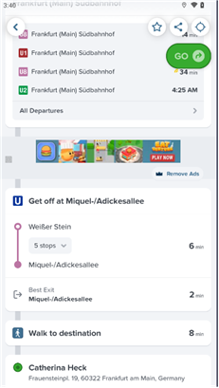
Fig 3. Citymapper interfaces‎[6].

SNCF Connect:

Description
SNCF Connect‎[7]. is a multi-purpose web application developed to allow the users of the SNCF transportation network in France to travel effortlessly through all the services provided by the network. It is developed with an intuitive interface and personalized features as shown in figure 4 that ease the journey process and increase the comfort of travel for the user. Users can benefit from features like route planning, real-time schedule updates, and ticket purchasing options, all accessible from their mobile devices.

Features:
- Integrate Transport Solutions: It integrates multiple means of transportation, offering users many ways of transportation
- Real-Time Information: It provides real-time information about train schedule status, including information on delays and platform changes, for the proper information-based making of travel decisions in good time.
- Personalized Features: With the application, features to save preferences, favorite routes, and customized notifications from user preferences and travel history are available.
- In-App Ticket Purchases: Purchase and manage tickets in the application. Users do not have to go to a ticket counter or vending machine to do it.
- Trip Planning: Optimized journey with recommendations on the best routes, including various transit modes to be used along the journey.
- Accessibility: The application includes assistance for users with reduced mobility, audio announcements, and visual aids to make the application more inclusive.
- Language Support: Can be used in several languages, so both domestic and international travelers can use the application.

Limitations:
- Ticketing Restrictions: Although tickets can be bought through the application, some types of tickets or promotion may have to undergo validation or another redemption process, which may be an inconvenience to the user.
- Resource Intensive: If certain features like real-time updates and GPS navigation are used continuously, they can be data- and battery-intensive, especially on older devices and on long journeys.
- Language Barriers: The application is supportive of more than one language, but the translation can have a margin of error and may leave non-native speakers confused or misinterpreting the content.
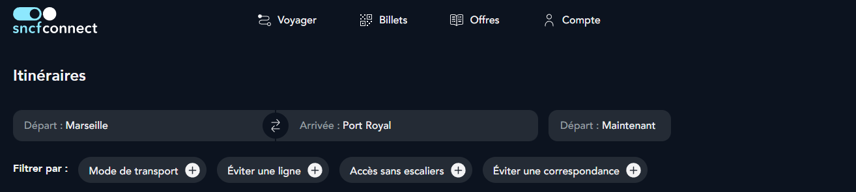
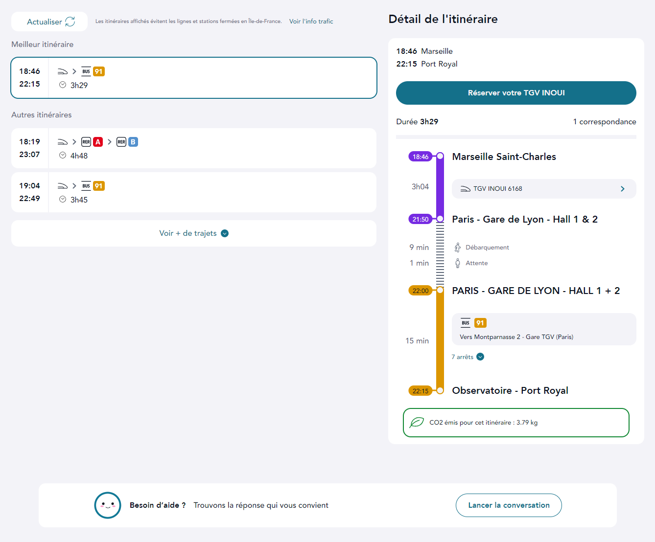
Fig 4. SNCF Result Page‎[7].
- Comparison table of existing applications:
In this section, we will compare the different applications that we found according to the following criteria:
- Support in Algeria: The system is designed to operate within Algeria
- Multiple modes of transport: It integrates various transportation options such as buses, trains, trams, taxis.
- Time calculation: The system provides accurate time estimates for the entire trip, including travel durations and any transfer times between different modes of transport.
- Indicate itinerary and all stops: it includes all stops, transfers, and final destinations.
- Support for multiple cities: The system works across various cities in Algeria, not just within a single city.
- Urban or inter-municipal itineraries: It supports both travel within cities and journeys between different towns or cities.
- Multiple route options: It offers several route alternatives, enabling users to select the most convenient, fastest, or cost-effective option based on their preferences.
- Cost calculation: The system calculates and displays the total cost of the journey.
- Schedule consultation: Users can access and review the schedules of different transport modes to plan their trips accordingly.
- Online booking: the platform allows for the online booking of tickets for various transport modes.
- Date selection: Users can choose specific travel dates and times.
- Real-time assistance: The system offers real-time customer support to assist travelers with any issues or changes during their journey.
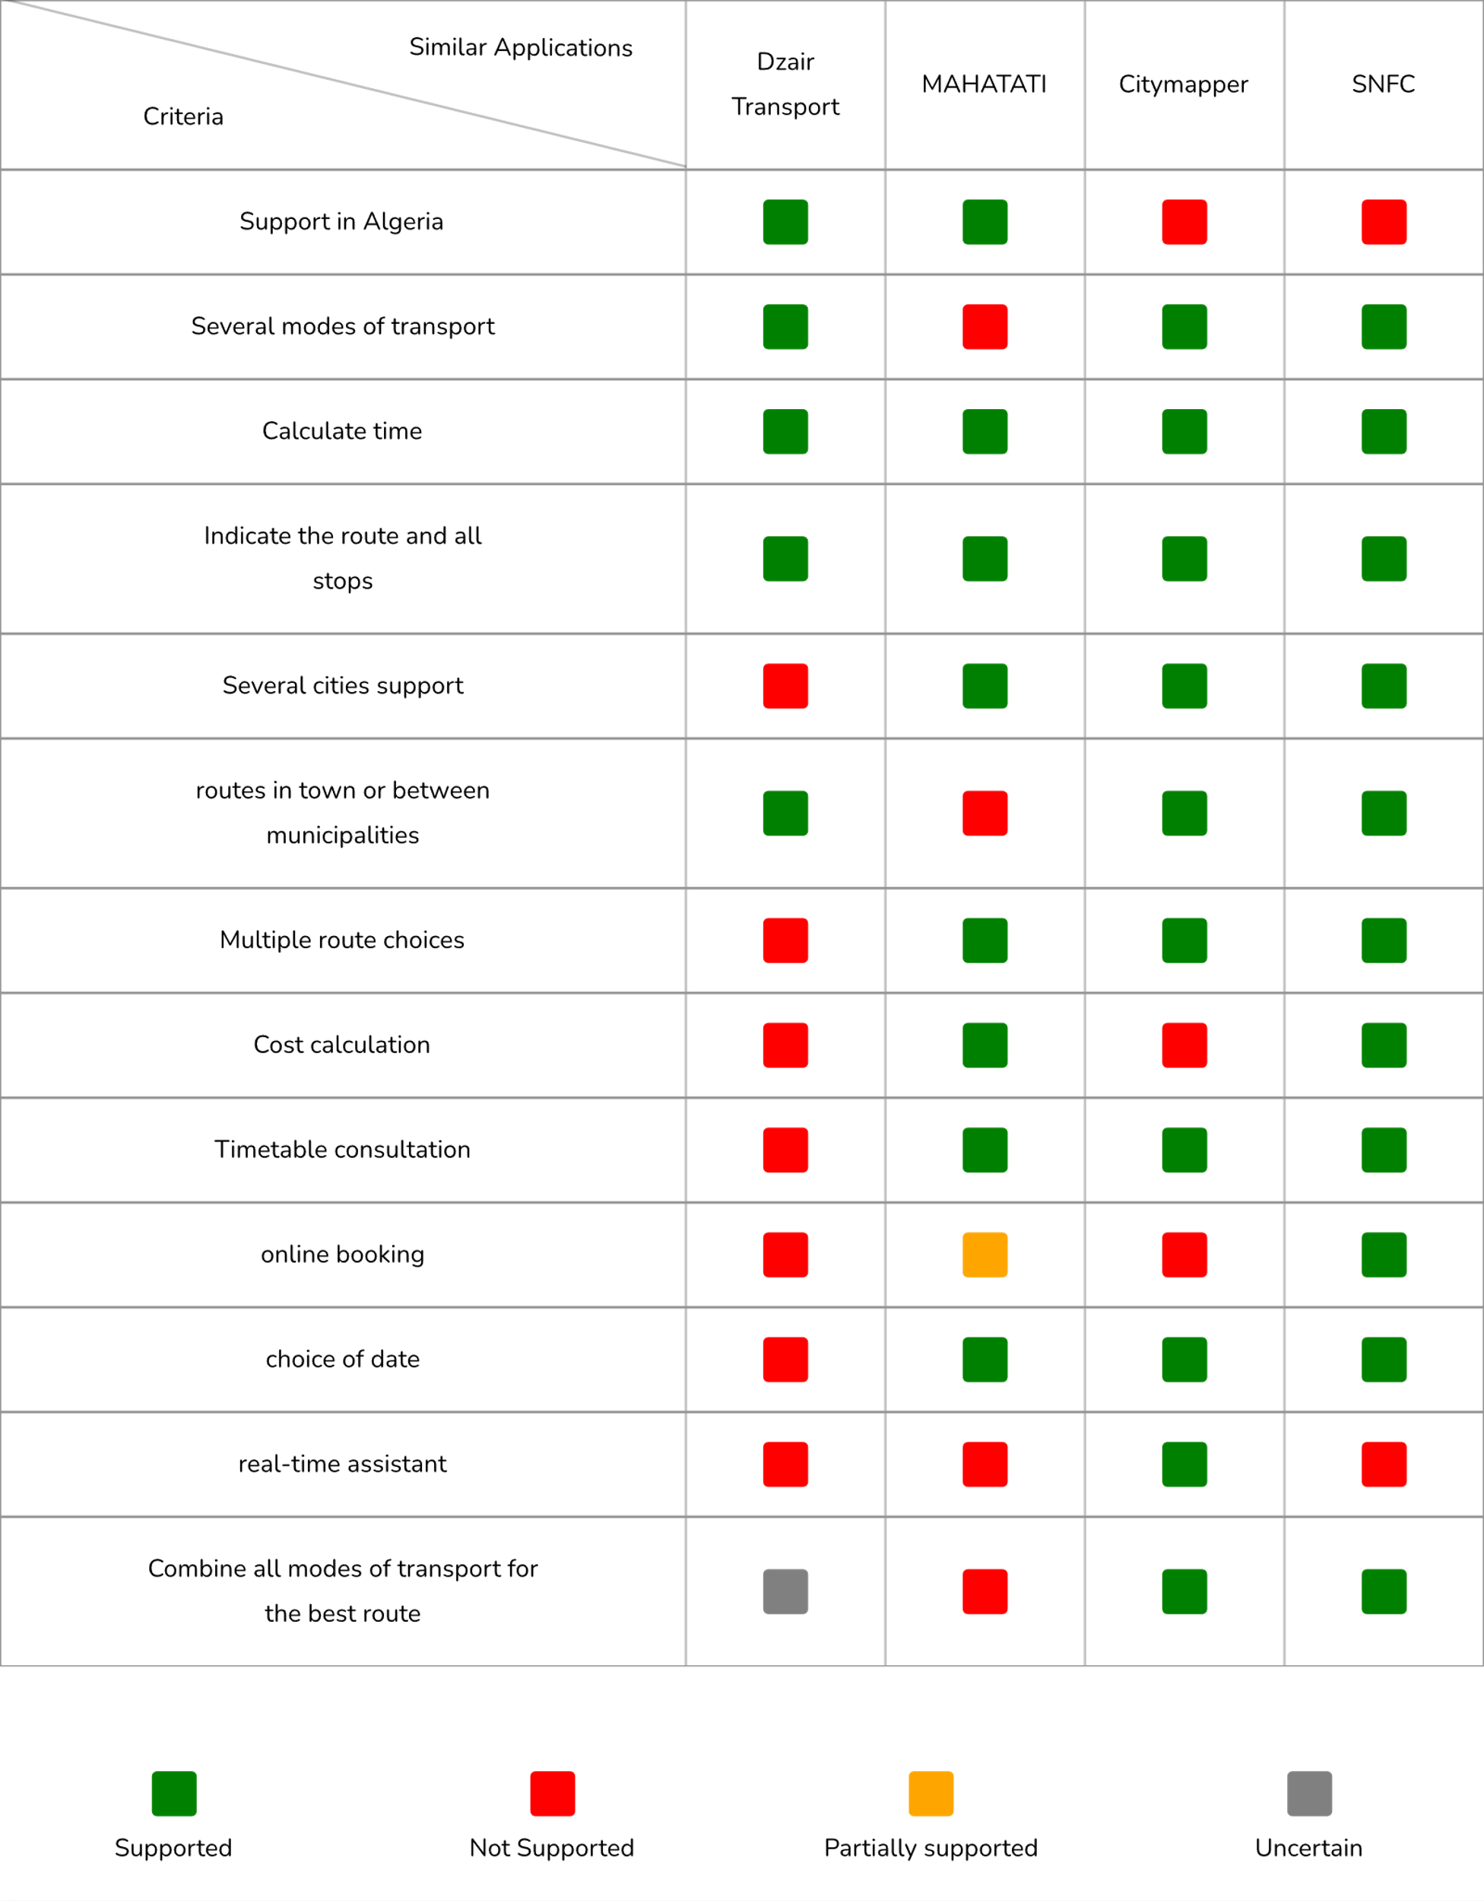
Fig 5. Comparison Table
The table above in figure 5 compares the various features offered by the mentioned applications. While some offer unique features, others lack basic functionalities such as different trajectories or the ability to calculate price or time. These applications have been developed for different purposes, and their motives vary. Some target transportation in small towns, while others focus on serving multiple cities around the world.
Altogether, these services offer the same core functionality, which is to help locals and foreigners traverse the local transportation system with ease. However, the lack of different features in various applications has created a gap for development. For example, the lack of support for Algeria.
To address the gap mentioned, we propose our solution, which includes all the necessary features to facilitate the use of transportation in the Wilaya of Tlemcen. This includes providing lacking functionalities such as time calculations, pricing, duration, seats booking, while the ability to create an account remains optional for effective use. Additionally, we plan to incorporate other useful features in the future.
- Conclusion:
Chapter 1 is entirely devoted to the current state of transport applications existing at home and around the world. This chapter covers the pre-existing solutions in Algeria, such as DzairTransport and MAHATATI, and Citymapper and SNCF Connect abroad. Their features, limitations, and overall effectiveness of these applications are checked, which help in urban and inter-municipal travel.
The analysis carried out highlights the fact that while these applications are useful in terms of functionality, there are large lapses in the contexts of Algerian needs in transportation. The key deficiencies identified are geographical, option for route choice, cost estimate not available, and user interface is outdated. The realization that comes out from these gaps is that an acute need exists for a solution that is more robust and inclusive.
Looking at the gaps in the existing systems based on the literature review, the proposed solution will incorporate such features as comprehensive time-cost calculation, multi-modal transport provision, real-time updating of information, and the user-friendly interface. The new application targets improving the overall traveling experience in the Wilaya of Tlemcen by providing reliable, available, accessible transportation information to the local residents and visitors who use it.

CHAPTER II: Needs Analysis and Design

- Introduction:
Mobility in Tlemcen is very difficult because there is no one spot from which it is possible to obtain all the data regarding public transport. Therefore, the uncertainty and the lackluster reliability in usage make the transport system a pain for everyone.
The overall project objective is to develop an application that enhances the quality of the transportation system for the city's inhabitants and visitors. The application will provide updated information on all types of transportation available (trains, taxis, and buses).
The application will show real-time schedule updates for routes. This will help users plan their trip better. It will also show all stops along each route, which makes it easier to understand how to get from one place to another.
The application will be particularly valuable for tourists as it will offer information in multiple languages, enabling them to navigate the transport system even if they don’t speak the common tongue. This enhancement will elevate their experience in Tlemcen, potentially inspiring them to further explore the region.
- Design
Our application is intended for the Wilaya of Tlemcen at first, to then gradually extend its reach to the whole of Algeria. by guaranteeing accessibility to all users, including those facing language barriers or visual impairments. In addition, mobile compatibility is essential for optimal accessibility on the go. Also, we consider the creation of a separate administrator dashboard for effective data management, user control and data visualization, accessible only with the correct administrator credentials, thus ensuring secure and reliable management of the platform.
This section will present different diagrams to showcase the interactions between the user and the application and each diagram plays a crucial role in providing a comprehensive understanding of the application's functionality and structure. We will also introduce the different roles this application expects, and the multiple functionalities it possesses.

Definition of Roles:

Administrator:
Description: The administrator plays a crucial role in managing the application. They are responsible for handling routes, including creating, modifying, updating, or deleting them for key locations in the city. They also manage user accounts and common locations.
Features:
- Routes management
- User management
- Cities and places management
- Reservation management

User:
Description: A user can be anyone using the application to navigate from one place to another, either occasionally or frequently, without creating an account. They can access most features, except for some that are exclusive to registered users.
Features:
- Get itinerary plans
- Check plan details

Traveler:
Description: A traveler is an authenticated user; they can access additional features and even personalize their experience.

Features:
- Plan multiple itineraries at a time
- Reserve / Unreserve seats
- Check previous trips
- Manage notifications

Functional Requirements by Actor:

Administrator:
- Manage Routes:
  - Add Route
    - Objective: Allow administrators to add new transport methods to the system.
    - Description: Administrators can add new transport methods to the system, including relevant data such as the type of transport and associated details.
  - Modify Route
    - Objective: Enable administrators to modify existing transport methods.
    - Description: Administrators can update details of existing transport methods to ensure the information remains accurate and relevant.
  - Delete Route
    - Objective: Enable administrators to remove obsolete transport methods from the system.
    - Description: Administrators can delete transport methods that are no longer in use.
- Manage Users:
  - Add User
    - Objective: Allow administrators to add new users to the system.
    - Description: Administrators can add new users by providing necessary information such as username, email, and password.
  - Modify User
    - Objective: Enable administrators to modify existing user information.
    - Description: Administrators can update details of user accounts, such as username, email, and password.
  - Delete User
    - Objective: Allow administrators to remove user accounts from the system.
    - Description: Administrators can delete user accounts that are no longer needed.
  - View User Details
    - Objective: Enable administrators to view detailed information about user accounts.
    - Description: Administrators can access complete profiles and activity logs of users.
- Cities and Places Management:
  - Add City
    - Objective: Allow administrators to add new cities to the system.
    - Description: Administrators can add new cities with details like name, provenances, streets, stops and hotspots.
  - Modify Cities
    - Objective: Enable administrators to update existing cities.
    - Description: Administrators can modify details of existing cities, such as provenances, streets, stops, and hotspots.
  - Delete City
    - Objective: Allow administrators to remove certain cities from the system.
    - Description: Administrators can delete cities that are no longer relevant.
- Reservation Management:
  - Cancel Reservation
    - Objective: Allow administrators cancel any user’s reservation.
    - Description: Administrators can cancel reservations.
  - Delete Reservation
    - Objective: Allow administrators to delete certain reservations from the system.
    - Description: Administrators can delete reservations that are no longer relevant.

User:
- Get Itinerary Plans:
  - Display The Resulting Plans
    - Objective: Provide a list of plans resulting from the itinerary query.
    - Description: Users can see query results, plans tagged by the three important criteria (cost, time, and convenience).
  - Show Plan Price and Estimated Time
    - Objective: Present each plan with its price and estimated duration.
    - Description: Users can view the plans cost and the estimated time.
  - Give an Overview of the Plan Steps
    - Objective: Briefly offer the option to visualize plan’s steps.
    - Description: Users can view the plans steps in less of details.
- Check Plan Details:
  - Display All Stops
    - Objective: Provide a complete list of all stops along the plan.
    - Description: Users can see all the stops included in the plan, allowing them to view the entire route at a glance.
  - Show Steps Price and Estimated Time
    - Objective: Present each step-in plan with its price and estimated duration.
    - Description: Users can view the steps cost and the estimated time.

Traveler:
- Plan Multiple Itineraries at a Time:
  - Objective: Allow travelers to have multiple planned and on-going itineraries.
  - Description: Travelers can plan multiple itineraries simultaneously and have access to all of them on demand.
- Reserve / Unreserve Seats:
  - Objective: Provide travelers with the ability to reserve or cancel reservation of seats for plan’s steps.
  - Description: Travelers can view their reservations, reserve seats, and unreserve them.
- Check Previous Trips:
  - Objective: Ensure travelers have access to all their previous itineraries.
  - Description: Travelers can see and remove all their previous trips whether it was done, cancelled, or missed.
- Manage Notifications:
  - Objective: Travelers have access to notifications feature, keeping them updated at all times.
  - Description: Travelers can see and take relevant action on their notifications

Non-Functional Requirements:
- Usability:
Specifies how user-friendly and intuitive a system should be for its intended users. It focuses on aspects such as ease of navigation, clarity of information presentation, and overall user satisfaction.‎[8]. The application should have a simple and modern interface that is easy for most people to use.
- Performance:
Performance defines the system's responsiveness, throughput, and resource usage under various conditions, ensuring efficient execution of tasks within acceptable timeframes‎[9]. Route search speed should be fast, and the application should be responsive and smooth, capable of handling multiple users simultaneously.

- Availability:
The application should be available at all times, especially during peak hours.
- Compatibility:
The application should be compatible with most smartphones, including plans for an iOS version if necessary.
- Security:
The application must ensure the security of user data, including personal information, through authentication systems and encryption protocols.
- Maintainability:
Maintainability outlines the system's ease of modification, updating, and troubleshooting over its lifecycle, facilitating efficient maintenance activities by developers‎[9]. The application should be easy to maintain and update, with clear documentation and efficient maintenance processes to ensure long-term stability and reliability.

Use Case Diagrams:
Use case diagram is a visual representation in UML that illustrates how a system interacts with its users or external systems by depicting various use cases and actors. It provides a high-level overview of the system's functionalities and the actors involved in using those functionalities‎[10].
The following diagram in figure 6 summarizes all the use cases associated with the User and Traveler, it focuses on the functionalities available to regular users and registered travelers such as planning itineraries, selecting destinations, and managing ongoing or previous trips. Regular users can search for and view itinerary details, while travelers can also make reservations, see their itineraries history and receive notifications.
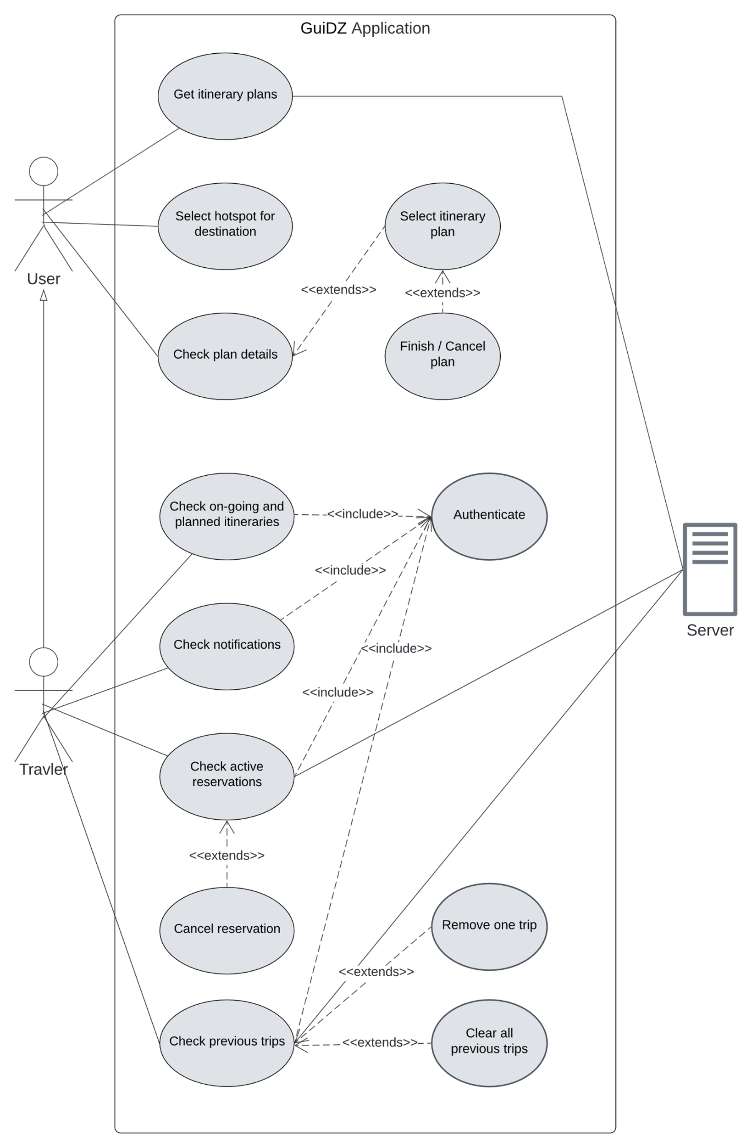
Fig 6. User Use Case Diagram

The following diagram in figure 7 summarizes all the use cases associated with the admin; this use case diagram highlights the actions available to system administrators. It includes managing user accounts, transportation routes, cities, and reservations. Administrators can add, edit, or delete data to ensure the system remains current and accurate, facilitating smooth operation for all users.
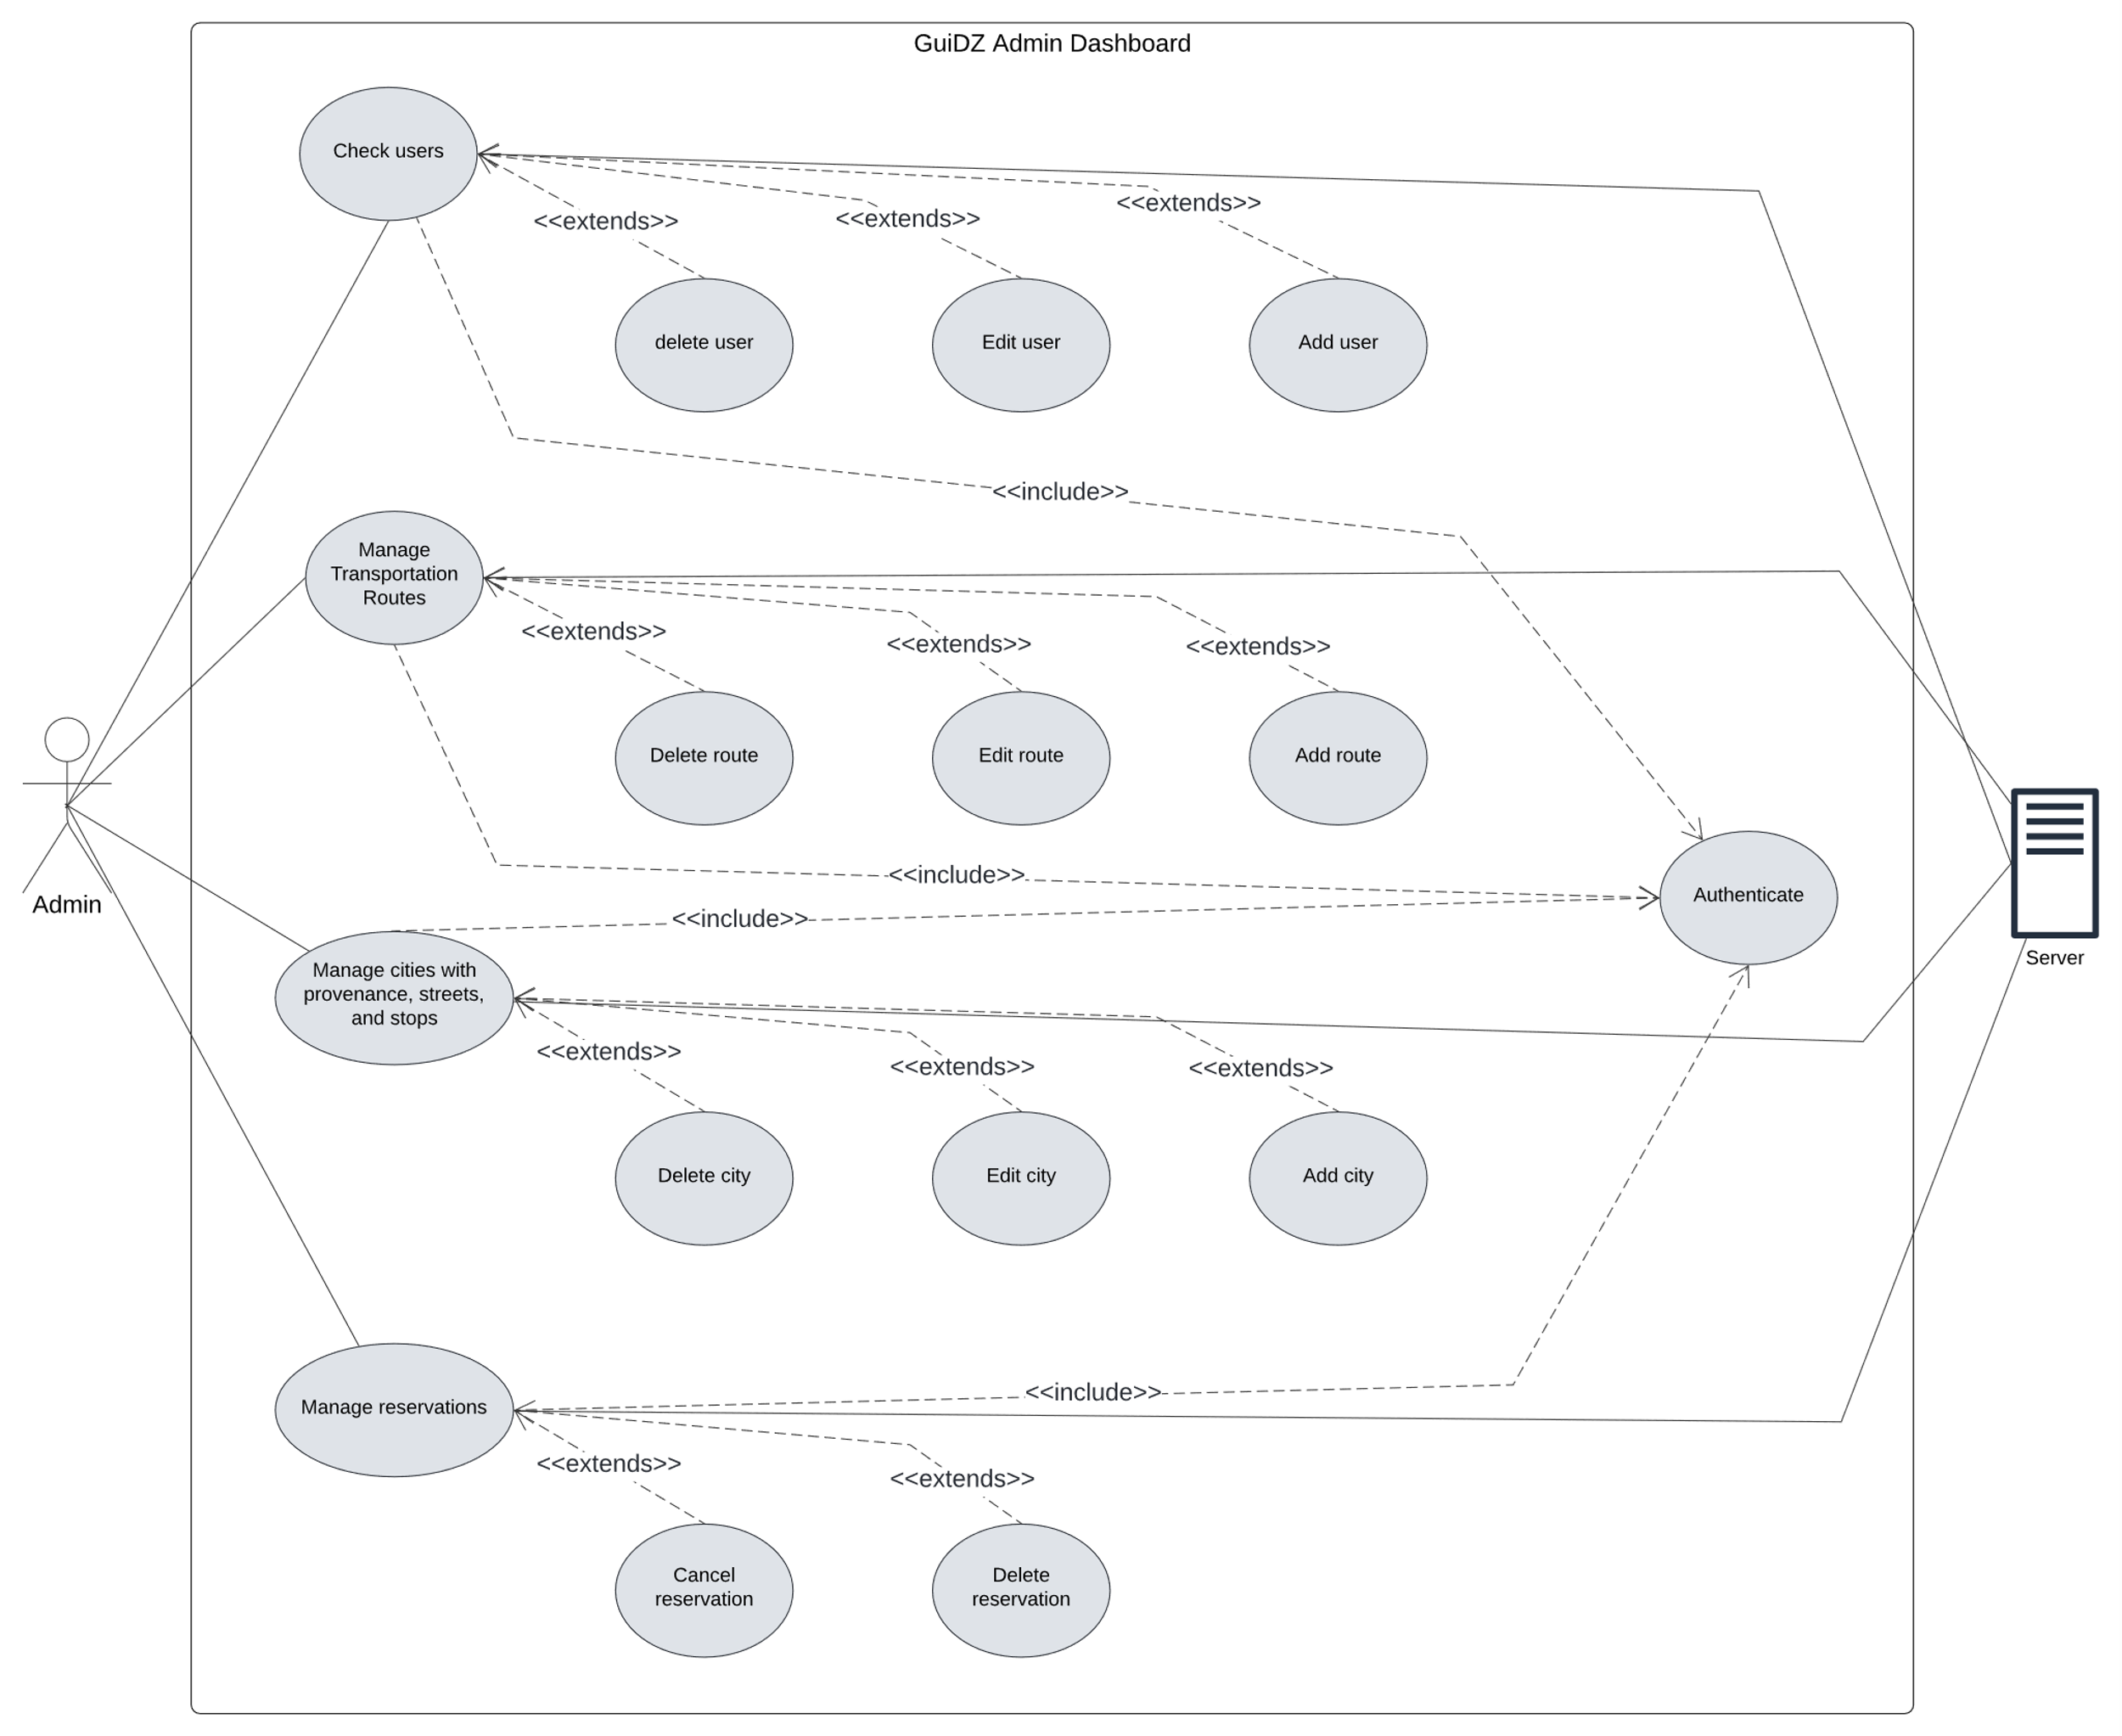
Fig 7. Admin Use Case Diagram

Sequence Diagrams:
A sequence diagram is a type of interaction diagram in UML that shows how objects interact in a particular scenario over time. It visualizes the sequence of messages exchanged between objects within a system, illustrating the flow of control and data‎[11].
The sequence diagram in figure 8 describes the registration of a traveler. It all starts when the traveler submits a registration form through the application. The registration data is verified in the database of the application. If the data is valid and the email is unique, the user is taken to the OTP page, where the user has to input the OTP sent through Supabase to his email that he entered. The OTP is verified. If the OTP is correct, then the user is taken to the home page. If the data is incorrect, or maybe the OTP is, the user is then alerted with the respective warning message.

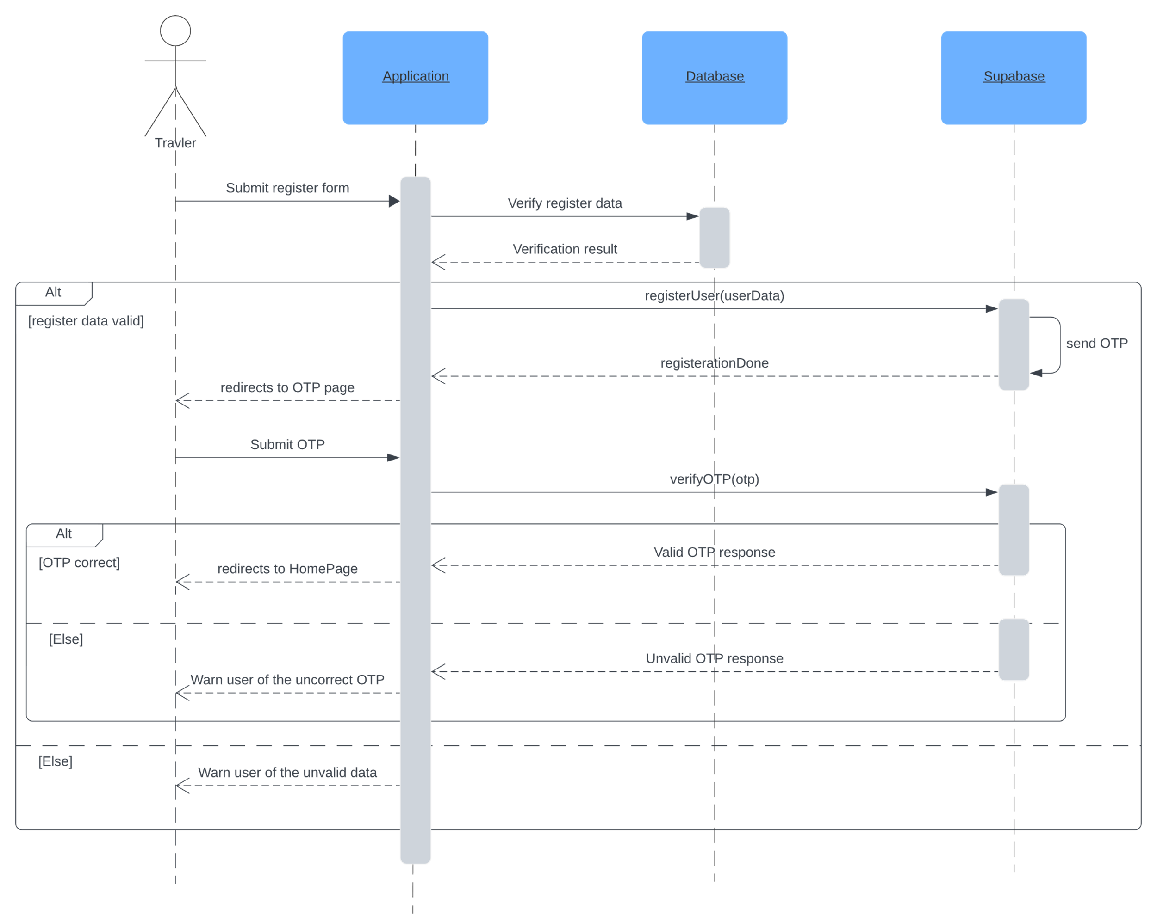
Fig 8. Register Sequence Diagram
The next sequence diagram in figure 9 contains the details that a user follows to search and select a route plan. Here is a much better explanation and description:
The user, via the application, types in his departure location name or only part of it. The application sends a search request to the database, which processes this request and returns the available locations that match the input. Then the user selects the desired departure location. The user then sets the destination location. Similar to the previous step, the user visualizes the results and selects the appropriate destination.
Once both the departure and destination locations are selected, the user may add additional information like number of seats and departure time, but for the sake of simplicity we leave the sequence diagram scenario at that. The user then performs a search. The application sends a request to the edge function to search different itinerary plans with different criteria. quickest plan, cheapest plan, and the easiest plan. The function then processes these requests and returns the corresponding results.
After processing the results. The application visualizes these plans to the user, allowing them to choose a preferred plan.
Once the user selects a plan, the application sends a request to the database to get detailed information about the selected plan. The database processes this request and returns the detailed plan information. The user then reviews these details.
Finally, the selection is confirmed by choosing the specific plan itinerary, this completes the search and selection process, providing the user with the most suitable travel route based on their preferences and the available options.
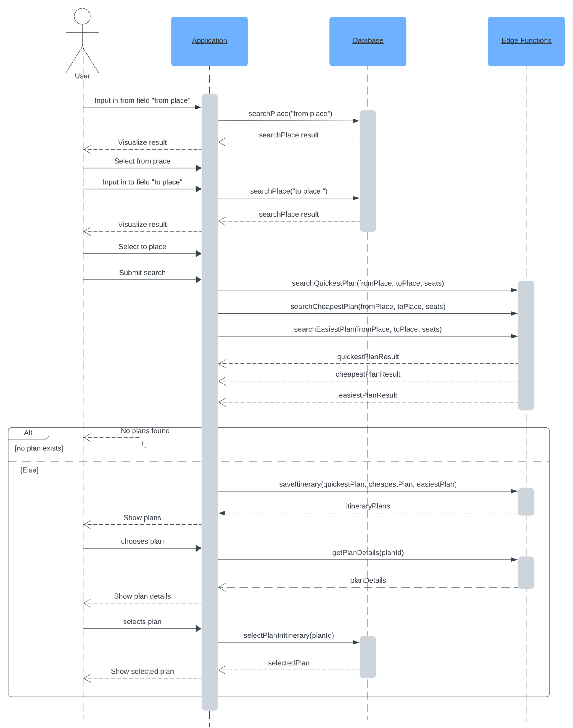
Fig 9. Search and select route Sequence Diagram
The last sequence diagram illustrated in figure 10 two main features for Travelers (authenticated users), multiple itineraries and reservation. The traveler can navigate to the itineraries page in the application, which retrieves ongoing itineraries from the database, the user then selects an itinerary or he can move to the planned itineraries tab. For the sake of explanation, the user selects a particular ongoing plan, then application fetches plan details and displays it. Traveler views the plan and clicks to reserve a trip (a step in itinerary plan). After submitting payment card information, the application sends reservation details to the edge function, which validates the card and checks seat availability. If the reservation is successful, the application displays the ticket. If not, it warns the user of the failure cause.

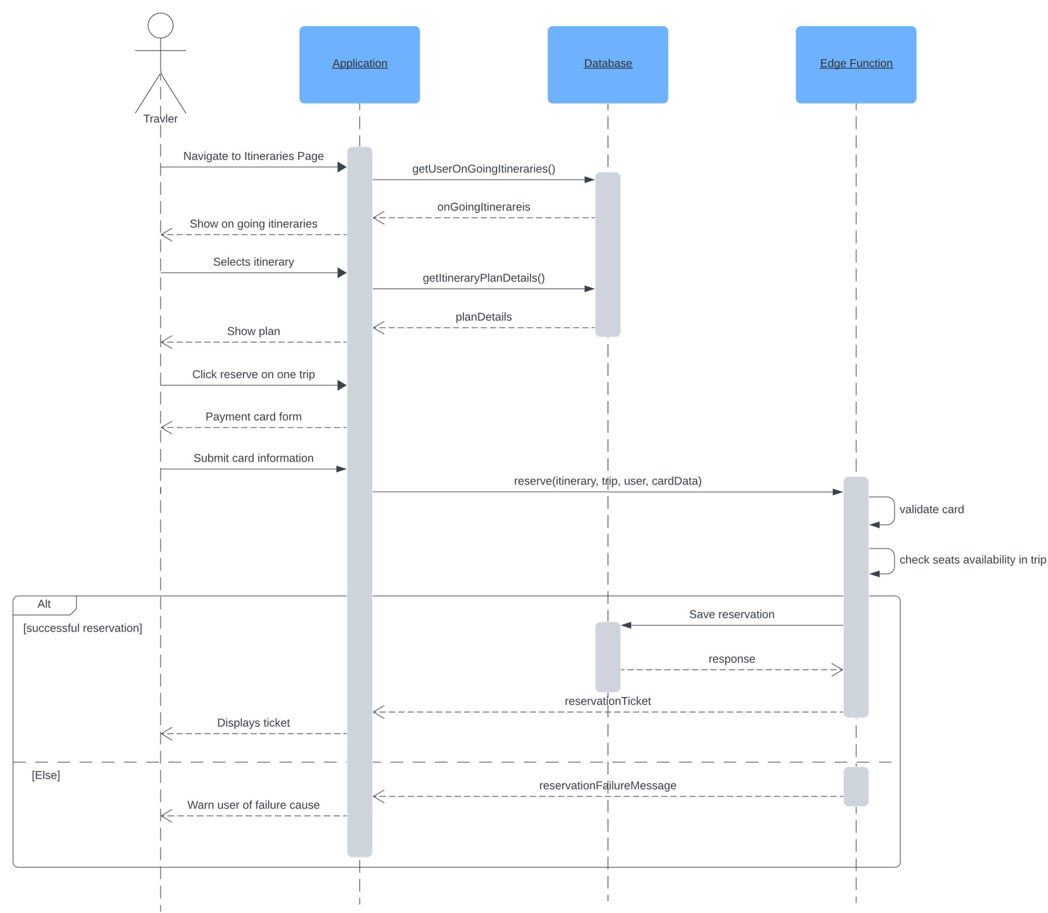
Fig 10. Search and reserve ticket Sequence Diagram

Class Diagram:
A class diagram is a static structure diagram that represents the structure of a system by showing the classes in the system, their attributes, methods, and the relationships among them‎[12]. This diagram describes the overall structure of our application system; it relates all classes, including Users, Trips, Routes, and Places. It is basically a description of a class, the relationship it shares, and the functionalities it can provide when integrated with other classes. The main components and their relationships are explained briefly below.
Diagram Explanation:
As show in figure 11, The regular user has the following attributes: id, name, telNum, address, and is capable of reset password, update profile, and itinerary plan search, etc. The administrator is inherited from the User Interface but has other features, such as the ability to manage other users, routes, cities, and reservations; attributes include email, password, and registerDate.
The classes Itinerary and Reservation are used to manage the travel itinerary of the users and their reservations. The Itinerary class holds its attributes like id, date, hour, and seats, and is capable of changing its states through changes such as planned, ongoing, canceled and so on. The Reservation class describes booking with its attributes, such as id, seats, and date; it provides the action of canceling or completing a reservation.
The class Notification is responsible for keeping the users notified of their itineraries and reservations, such as planned travels and missed reservations. The class has its attribute, id, type, and body, thus detailing the notification content. The class Trip describes a journey that involves many places with its attributes described through id, date, time, and number of seats. This class main purpose is to keep track of available seats through the journey of the trip.
The city class has characteristics such as id and name. Places are described by the class Place, with characteristics such as id, fullName, provenance, street; these are concrete specific places in the city. In each place there can be found several stops, implemented by the class Stop, with characteristics id and coords, which describes the location of the stop. Stops describe a point in a place where route trips may stop and transfers (foot paths) might be available to link it with another stop.
Hotspots will be represented by the Hotspot class, which will contain attributes such as id, name, and cover. The important thing to note is that hotspots are associated with cities and places. They help identify important or popular spots within the system.
Routes are formed from a series of stops; hence, class Route includes identifiers, name, acronym, type, seatsCount, tripDuration, and tripPrice, which describes the parameters of its trips. Foot paths are described by the class Transfer, which has the attributes id, time, and distance. These foot paths relate two stops to each other, making them accessible from one end to another.
This system would also consist of classes such as Times, Fares, Scheduled, and Rotation, all of which will manage details regarding operations. The Times class would have trip schedules with fields such as id, departures, and arrivals, which will be key for planning. The Fares class would define fields such as id and cost, which would be associated with the route's pricing. The Schedule and Rotation classes would help in the regulating route trips. Each route must only have one of these classes related to it and only one, Rotation represents a route that has no scheduled departure times yet relies on intervals of time (minutes) between trips, it contains fields like id, startTime, endTime, and interval. On the other hand, schedule class represents the opposite of rotation, a scheduled route has fixed departure times. Departure class includes id and startTimes, an array that represents the time in day of which these trips start.
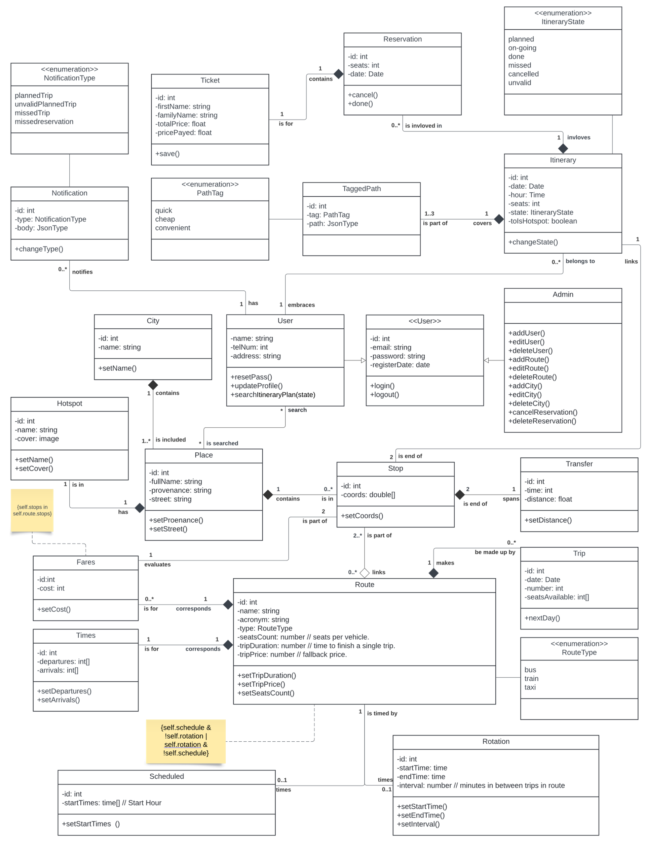
Fig 11. Class Diagram

- Conclusion:
In this chapter, we dived deep into the fundamental elements required in developing the system. In fact, the main content of this chapter deals with diagrammatic representations and identification of functional and non-functional requirements.
Diagrammatic representations including use case, class, and sequence diagrams helped to understand in a visual and structured way the interactions within the system, its architecture, and the flow of data. The use case diagrams depicted the interactions that occurred between the users and the systems, basically outlining the main functionalities and user scenarios that could be identified within the system. The class diagram gave a detailed view of the structures of the system: it showed the relationships and attributes of different classes within the application. While sequence diagrams enriched our understanding further, depicting the sequence of exampled events and interactions between objects over time.
Functional requirements were analyzed to identify the set of functions the system must have to meet the user's needs and business objectives. Such requirements would ensure the system performed its intended tasks, such as authenticating users, manipulating itineraries, and sending notifications in real time.
The non-functional requirements identified the general qualities and constraints the system must adhere to, such as its performance, security, usability, and scalability. This set is critical in ensuring that the system will not only be functional but also reliable, efficient, and user-friendly.
In conclusion, this chapter allowed us to have a solid overview of the architecture and structure of our application. It helped us make important technical decisions to ensure an optimal user experience and a solid foundation for the development of our application.

CHAPTER III: Realization and Development

- Introduction:
In this chapter we will focuses on the realization of our transportation management system that we choose the name of GuiDZ for referring to the verb guide and DZ which is short for dzair or Algeria and a logo that can be seen in figure 12. We have developed a comprehensive application that integrates the main functionalities required for effective travel planning and management. This includes a web application for managing and viewing user, cities, routes and reservations, a mobile application for users to navigate routes and access information on the go, we will also discuss the choices of technologies and tools that we have made throughout the project, and showcase the different interfaces for each platform

Fig 12. GuiDZ Logo
- Tools and technologies used:

Technologies used:
- React: React (also known as React.js or ReactJS) is a free and open-source front-end JavaScript library for building user interfaces based on components. It is maintained by Meta (formerly Facebook) and a community of individual developers and companies.
React is a JavaScript library for building user interfaces. It is used for creating reusable UI components and managing the state of these components. React is not a full-fledged framework but rather a view library that can be used with other libraries and frameworks. It allows developers to build reusable UI components and manage the state of these components using its virtual DOM (a lightweight in-memory representation of the real DOM). This approach improves the performance and efficiency of the application by minimizing the number of DOM mutations ‎[13].
- React Native: React Native (also known as RN) is a popular JavaScript-based mobile application framework that allows you to build natively-rendered mobile applications for iOS and Android. The framework lets you create an application for various platforms by using the same codebase‎[14].
React Native is a framework for building native mobile applications using React. It allows developers to build cross-platform applications for Android and iOS using JavaScript and React. React Native uses a combination of JavaScript and native code to provide a seamless user experience. It also provides a set of pre-built components and APIs for common mobile features such as navigation, storage, and networking‎[14].
- NextJS: Next.js is a React framework for building server-side rendered and statically generated websites and applications. It provides features such as routing, rendering, data fetching, and optimizations. Next.js allows developers to build fast, scalable, and secure web applications by providing a set of pre-built components and APIs for common web features such as routing, data fetching, and caching‎[15].
- Deno: Deno is a modern JavaScript runtime that allows developers to run JavaScript and TypeScript code securely and efficiently. It is designed to be a more secure and reliable alternative to Node.js. Deno provides a set of built-in modules for common tasks such as file I/O, networking, and cryptography, and it also supports TypeScript and other modern JavaScript features‎[16].
- Tailwind: Tailwind is a utility-first CSS framework that allows developers to write more concise and maintainable CSS code. It provides a set of pre-defined classes for styling HTML elements, allowing developers to focus on the structure and content of their application rather than the presentation. Tailwind also provides a set of pre-built components and utilities for common CSS tasks such as spacing, sizing, and colors‎[17].
- PostgreSQL: PostgreSQL is a powerful, open-source relational database management system (RDBMS) that is widely used for storing and managing data in web applications. It provides a robust set of features for data modeling, data storage, and data retrieval, including support for transactions, indexing, and views. PostgreSQL is highly scalable and can handle large amounts of data and high traffic‎[18].
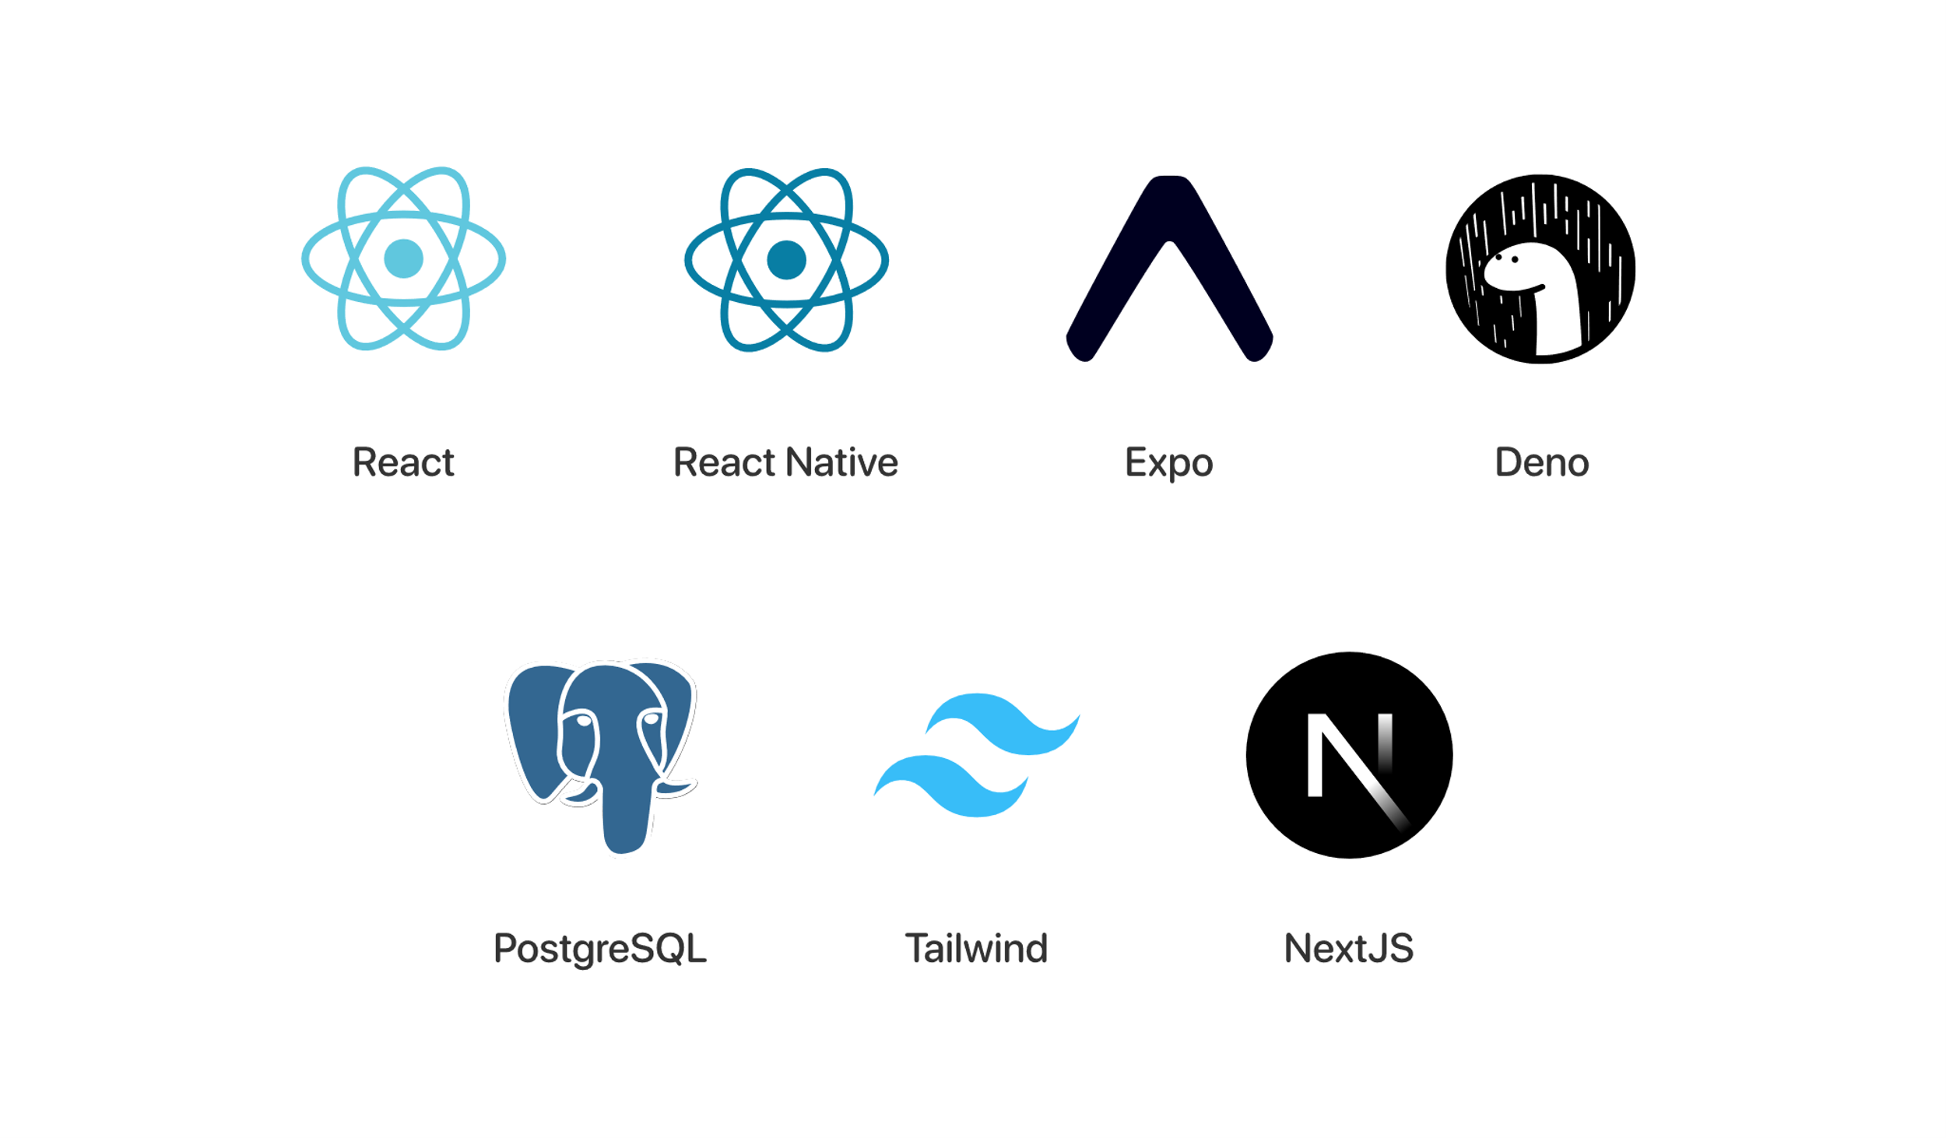
Fig 13. Technologies Used

Tools used:
- Visual Studio Code: Visual Studio Code is a source code editor created by Microsoft and designed to be lightweight while also having more power than the average text editor. It is also a source code editor used for building and debugging modern web and cloud applications. It is cross-platform and available on Windows, macOS, and Linux. It supports JavaScript, TypeScript, and Node.js, and provides support for debugging, embedded Git control, syntax highlighting, intelligent code completion, snippets, and code refactoring. And, of course, there's an extension marketplace for adding languages, debuggers, and other tools into Visual Studio Code‎[19].
- Project IDX: Project IDX is a completely web-based, integrated development environment. IDX can help you build and deploy applications in several tech stacks without the tedium of setting up development environments for yourself and others on your team. IDX runs on pre-configured VMs on Google Cloud to keep your development environment reliable, safe, and fully customizable like a local development environment‎[20].
- Expo: Expo is a free and open-source platform for making universal native applications for Android, iOS, and the web with JavaScript and React. It is a free and open-source platform to build universal native applications with a single codebase. It includes a set of tools and services that help you build native, cross-platform applications in a single JavaScript codebase. The main key feature is that it allows developers to abstract away the details of the devices and operating systems they are targeting so they can focus on building the application rather than working on building separate applications for both platforms‎[21].
- Expo Go: Expo Go is a mobile application that makes you run your Expo applications on your device without building a standalone application. This is an easy way to preview and test your Expo application while developing it. There is a feature set provided by Expo Go which allows running your application on your device with simulator, debugger, and tools for testing and debugging‎[22].
- Supabase: Supabase is an open-source alternative to Firebase, striving to give developers the necessary backend-as-a-service tools for building web and mobile applications. It houses features of authentication, Realtime databases, and storage, which is why it becomes one of the most opted-for options when developers need to build applications on a very large scale and securely. It features an architecture that has been meticulously crafted to offer high degrees of flexibility, combined with a wide selection of APIs and tools to build and integrate with other services‎[23].
- Figma: A design and prototyping application, Figma is a perfect tool for UI and design systems with full-fledged collaboration. It enables a designer and developer to work together on a design project, therefore making it very popular with teams and large organizations. Figma offers a wide range of features for design and prototyping, including vector graphics, layout tools, and animation capabilities‎[24].
- Docker: Docker is an open-source platform that helps developers build, deploy, and manage applications in a containerized version. This way, the developer can pack the application and all the dependencies into one container and have the application work in any environment. Docker provides a wide range of features for building and managing containers, including image management, network management, and volume management‎[25].
- Nox: Nox is an Android emulator that lets you use Android applications on your computer. Users mostly use it for Android application testing and debugging applications, but equally, it can be used to run Android games on PCs. Nox has some features that allow you to run Android applications on your computer. It's got some tools for debugging and testing, a feature for multiple instances, and configuration is also available‎[26].
- LucidChart: LucidChart is one of the best applications for a flowchart and diagramming tool that helps create the best kind of flowcharts, including flow diagrams, mind maps, and UML diagrams. It is majorly used for planning software projects and documenting them, enabling one to create the documents for presentation, such as presentations and reports. It offers a wide range of features to create and customize diagrams using a set of templates, shapes, and options for formatting‎[27].
- GitHub: GitHub is a web-hosted service for version control using Git. It helps developers working on open-source projects share source codes, make changes, and work together in repositories or projects. GitHub comes with a lot of features to manage and share code, including tools to track changes, issues, and features and to work together with other developers‎[28].
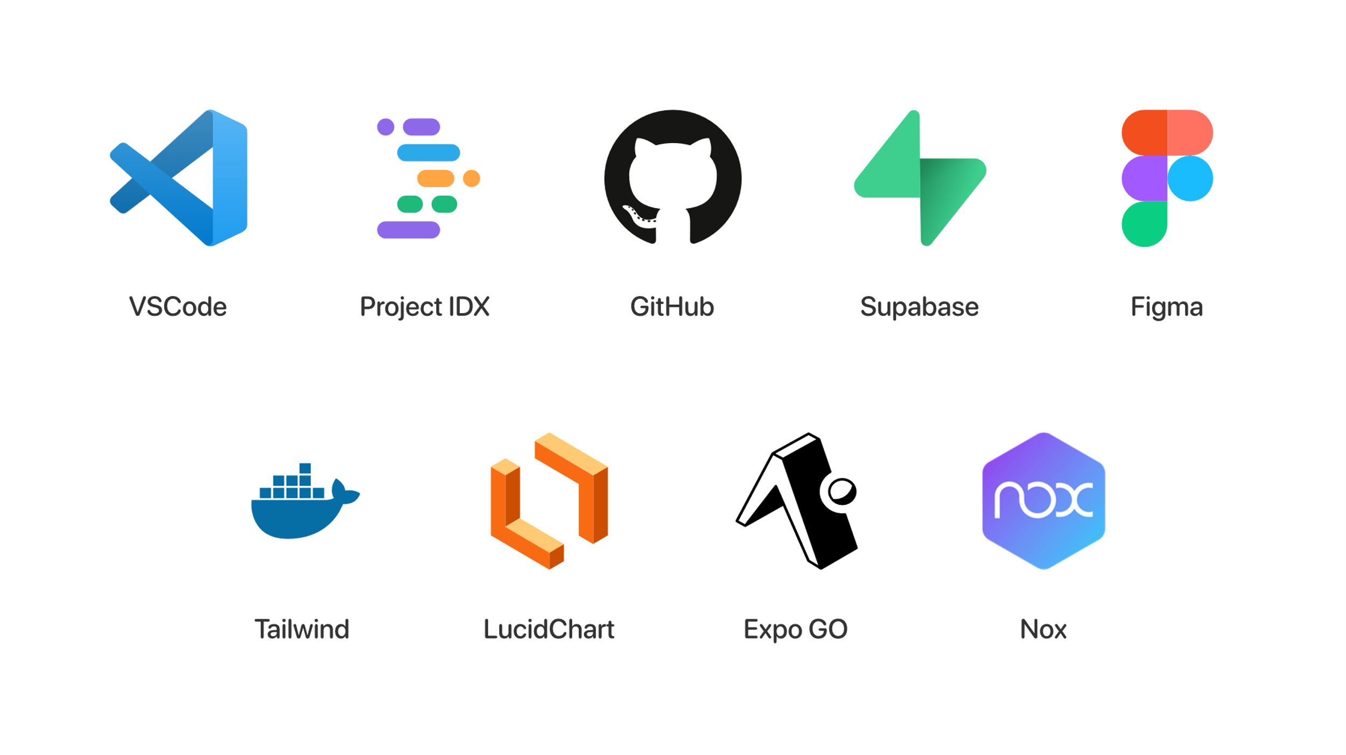
Fig 14. Tools Used
- Concept Challenges:

Basics:
Managing basic challenges like authentication and authorization, styling and testing were easily done thanks to the tools and technologies we’ve selected for this project. Supabase managed all the authentication and authorization, Tailwind done all the styling, and Expo Go was a great tool for testing the mobile application. Overall, there weren’t any big challenges starting up.

Algorithm:
Once we finished the groundwork for the application, we faced our main challenge. The algorithm of which the application’s main purpose is based on. We knew that traditional algorithms like Djikstra and all its variation won’t suffice for the main reason of performance, the amount of query calls will be too heavy for the server to handle. After extensive research we discovered RAPTOR, a round-based algorithm tailored specifically for public transit.
However, although the algorithm was designed for the soul purpose of finding the best plan through public transit networks, it still had to undergo changes for it to meet our requirements. We had to find a way to involve our seats condition into the mix and also get three plans for the three criteria we have time, cost, and convenience‎[29].
To address this, we modified conditions in 2nd and 3rd stage of the algorithm, this can give us what we need based on what we are conditioning, testing for cost will lead us to the cheapest plan, while assessing for time will give us the fastest one. Also, with the removing of the 3rd stage we can eliminate foot-paths from the algorithm, and thus building our last piece, the easiest plan.
Seating conditions were addressed by modifying the function earliestTrip (et (r, p)), replacing it with earliestTripWithSeats (etws (r, p, s) where 's' represents the number of available seats required for the trip to be valid). This adjustment ensured that only trips with available seats could be considered for planning.
Altogether, we modified the original RAPTOR‎[29]. algorithm to get us what we desire with the least of changes to make sure that performance is intact. The resulting pseudocode is as follows.
 | Custom RAPTOR Algorithm {criteria, sourceStops, targetStops, departureTime, seats (default = 0), roundLimit (default = 10)}
1 | Initialize arrivalTimes to an empty Map
2 | Initialize costs to an empty Map
3 | Initialize markedStops to an empty Set
4 | foreach stop in sourceStops do
5 |  | arrivalTimes[stop] = departureTime
6 |  | costs[stop] = 0
7 |  | markedStops.add(stop)
8 | for k from 1 to roundLimit do //Main loop
9  10 |  | // Accumulate routes serving marked stops from previous round  clear Q
11 |  | foreach stop in markedStops do
12 |  |  | if route is already in Q with a later stop then
13 |  |  |  | Update Q with the earlier stop
14 |  |  | else Add route to Q
15 |  | Clear markedStops
16  17 |  | // Traverse each route  foreach (route, startingStop) in Q do
16 |  |  | t = etws (route, startingStop, arrivalTimes[startingStop], seats)
18 |  |  | foreach stop in route starting from but not including startingStop do
19 |  |  |  | if t ≠ ⊥ and (criteria is time or convenience) and arrival time of t at stop < min(arrivalTimes[stop], arrivalTimes[targetStops]) then
20 |  |  |  |  | arrivalTimes[stop] = arrival time of t at stop
21 |  |  |  |  | markedStops.add(stop)
22 |  |  |  | if t ≠ ⊥ and criteria is price and (arrival price of t at stop + costs[startingStop]) < min(costs[stop], costs[targetStops]) then
23 |  |  |  |  | arrivalTimes[stop] = arrival time of t at stop
24 |  |  |  |  | costs[stop] = arrival price of t at stop + costs[startingStop]
25 |  |  |  |  | markedStops.add(stop)
26 |  |  |  | if arrivalTimes[stop] ≤ departure time of the next trip at stop then
27 |  |  |  |  | t = etws (route, stop, arrivalTimes[stop], seats)
28 |  |  |  |  | startingStop = stop
29  30 |  | // Look at foot-paths  if criteria are not convenience then
31 |  |  | foreach stop in markedStops do
32 |  |  |  | foreach foot-path (stop, nextStop) in foot-paths do
33 |  |  |  |  | newTime = arrivalTimes[stop] + walking time to nextStop
34 |  |  |  |  | if criteria are time and newTime < arrivalTimes[nextStop] then
35 |  |  |  |  |  | arrivalTimes[nextStop] = newTime
36 |  |  |  |  |  | markedStops.add(nextStop)
37 |  |  |  |  | if criteria are price and costs[stop] < costs[nextStop] then
38 |  |  |  |  |  | costs[nextStop] = costs[stop]
39 |  |  |  |  |  | arrivalTimes[nextStop] = newTime
40 |  |  |  |  |  | markedStops.add(nextStop)
41  42 |  | // Stopping criterion  if markedStops is empty then break

- Interfaces of the system:
Because the system is composed of 2 parts, mobile and web we will split it into two parts, first we start with web

Web part Interfaces:
- Login: To access the web dashboard, the user must login with their email and password as show in the form of figure 15, only users with admin privileges can login to the dashboard making it more secure, furthermore protecting the data and its integrity
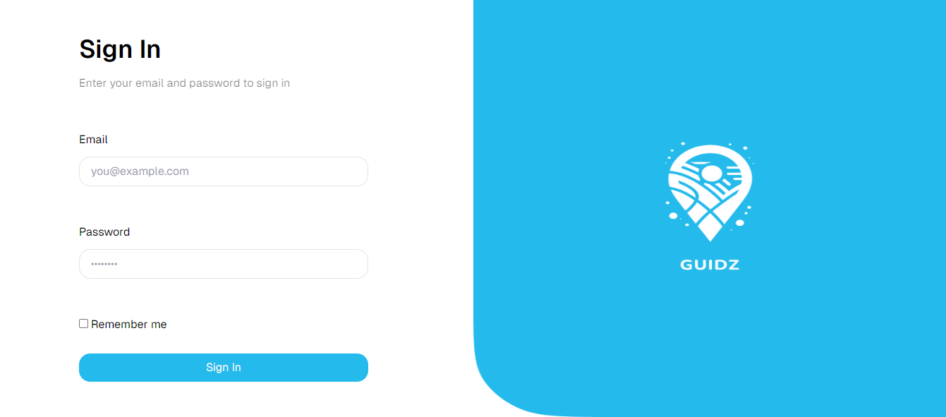
Fig 15. Login Page

- Dashboard: The first page figure 16 contains some statistics that helps evaluate the activity of the mobile application you can track the total amount of users, number of new users, and line chart that shows the new users registered each month, alongside with some extra statistics like the activity log and the reservations percentages.
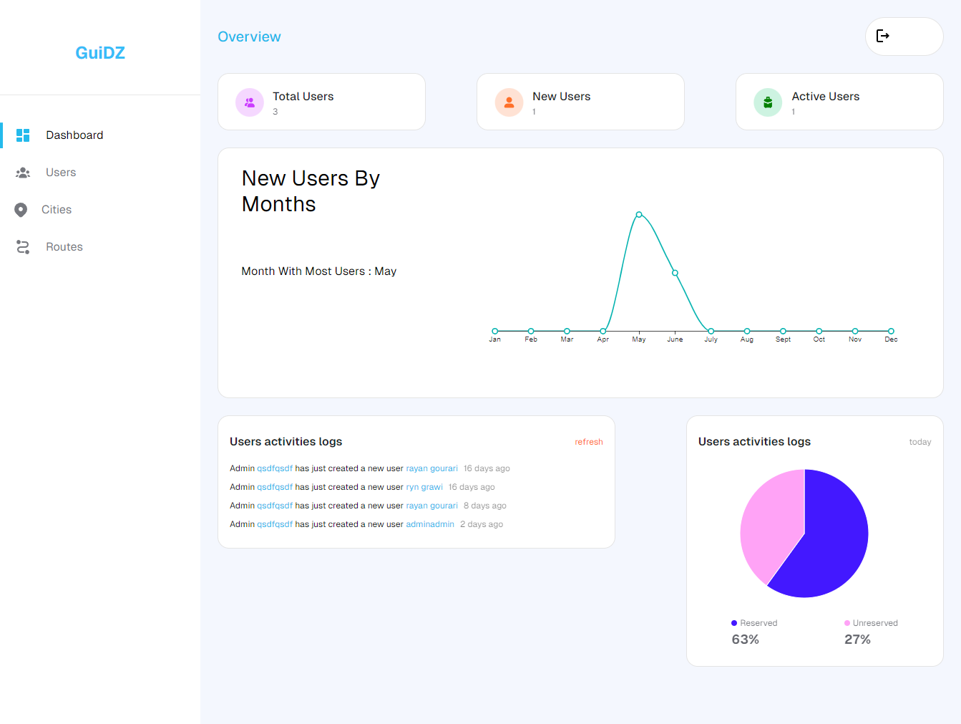
Fig 16. Dashboard Overview Page

- View Users: On the page shown in Figure 17 the admin has access to a list of all users including admins where he can search or filter by city or status that indicates where it’s a user or an admin, and has the abilities to edit one’s name or other info except for email and password, he can also delete users or view their reservations as explained in figure 18.
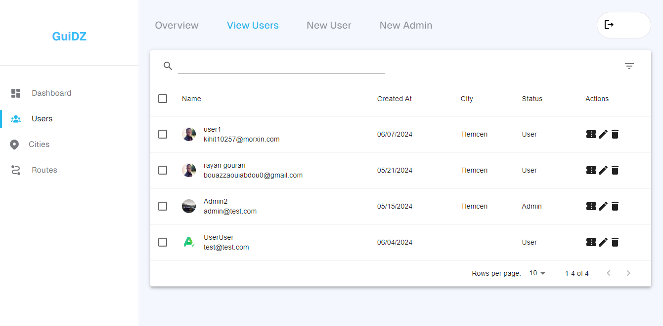
Fig 17. View Users Table

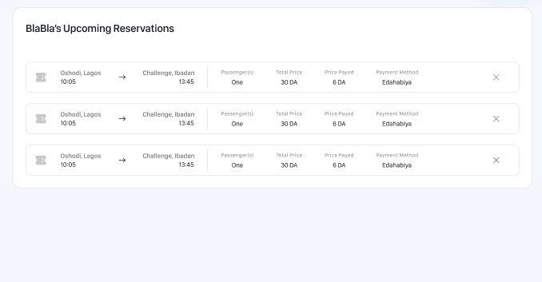
Fig 18. Users Reservations.
- New User: The Figure 19 represents the form for creating a new user through the admin dashboard it contains the users name, email and password these forms are required to be filled unlike the other fields which are not required, after submitting the form a message notification will display if the creation was successful and the user will be automatically verified, if not it will display an error message.
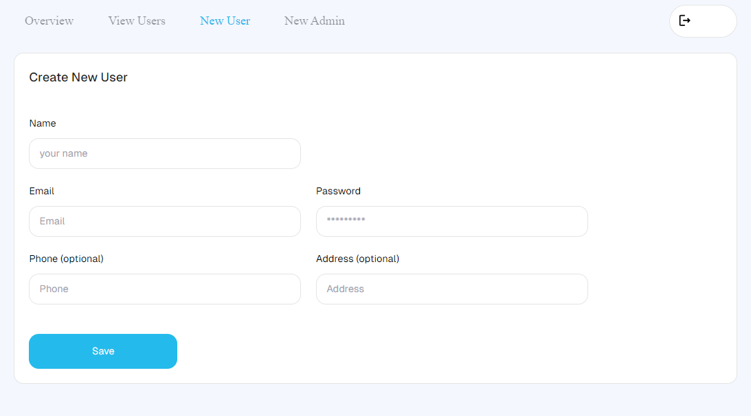
Fig 19. Create User Form
- Create Admin: And the one in Figure 20 is for creating a new admin; after submitting the correct information and making sure the email is unique it will then create a new user and give it administrator privileges.
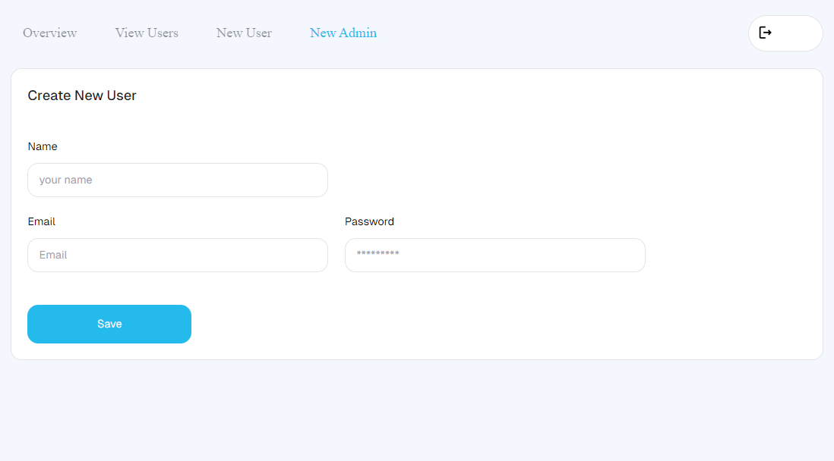
Fig 20. Create Admin Form
- Cities Overview: The page shown in Figure 21 is the overview of the cities part, it contains some useful statistics about number of reservations for each month, a section for logging itineraries as well as a pie chart that displays the most used transportation method.
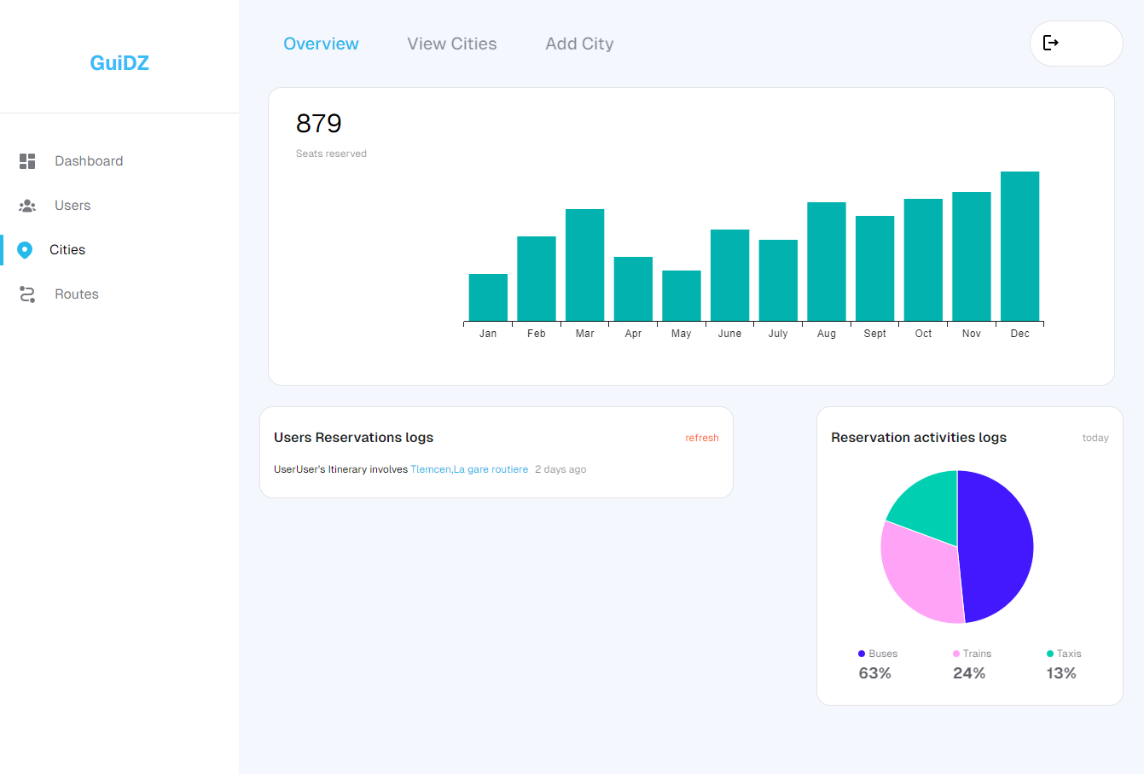
Fig 21. Cities Overview Page

- View Cities: The view cities page in figure 22 and 23 is a table where all the cities and their information are displayed in order, the name and city number, number of provenances, number of streets, number of stops and hotspots, from this the admin can either view, delete or edit and existing city
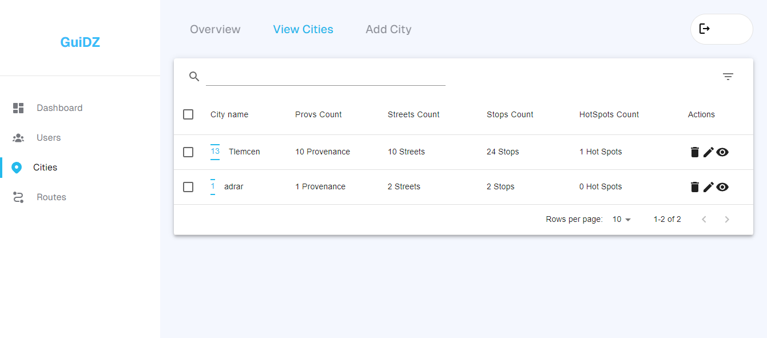
Fig 22. View Cities Table

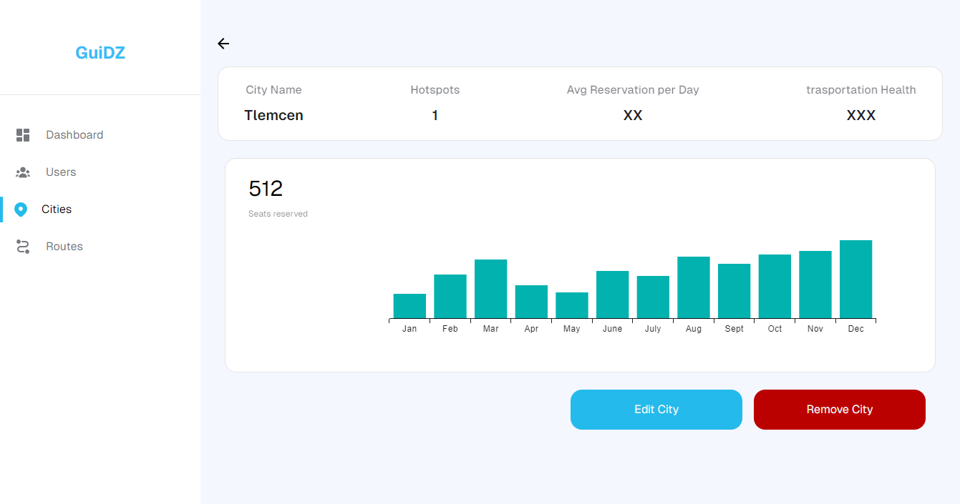
Fig 23. View City Info

- New City: This group of interfaces from figure 24 to 28 is how the admin is able to add or edit a city, the city information needs to filled first then you can add the provenances each with their number of streets and then for each provenance you fill the streets data which is the name of the number of stops that can either 0 or multiple, and lastly the hotspots each hotspot is linked to a street that way it is easier to navigate to, there can be multiple hotspots
The same thing is for editing except the city information are already there.
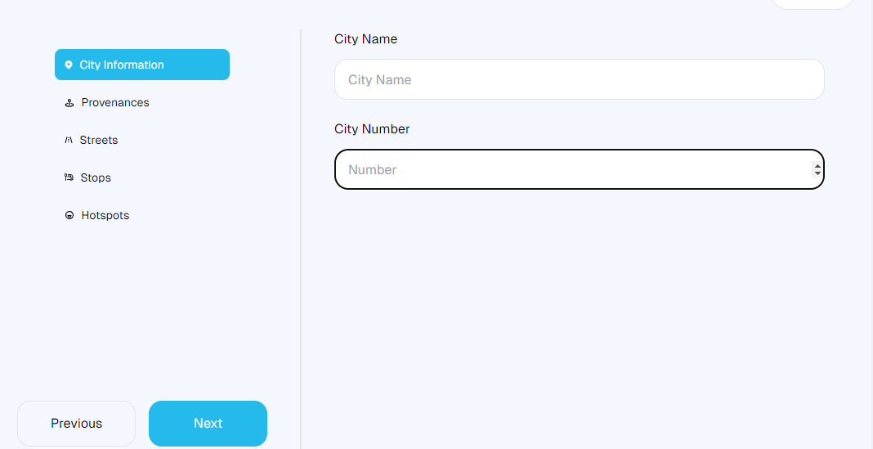
Fig 24. City Information
In the first step you must fill the city information which are the name and its corresponding number
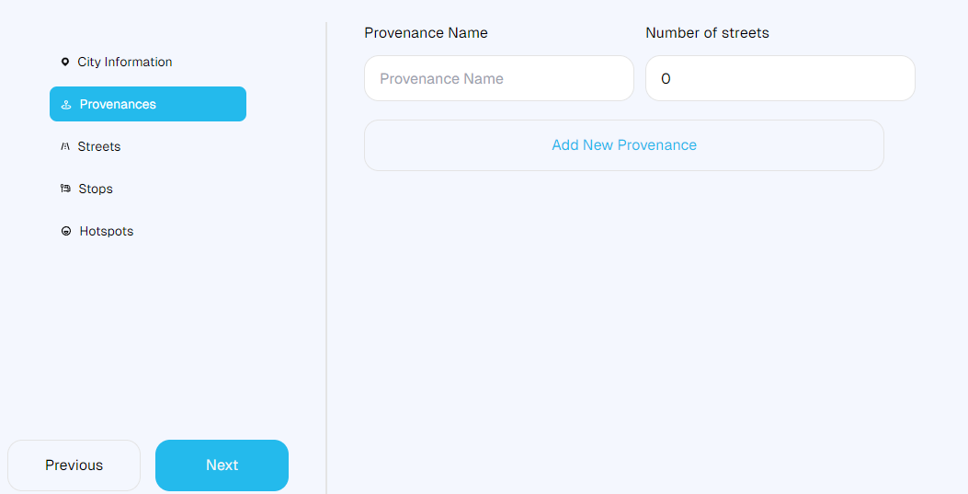
Fig 25. Provenances
After filling the city information, you click next to move to the next step, provenances which are considered as municipalities you can add many as your city has with each one having a number of streets
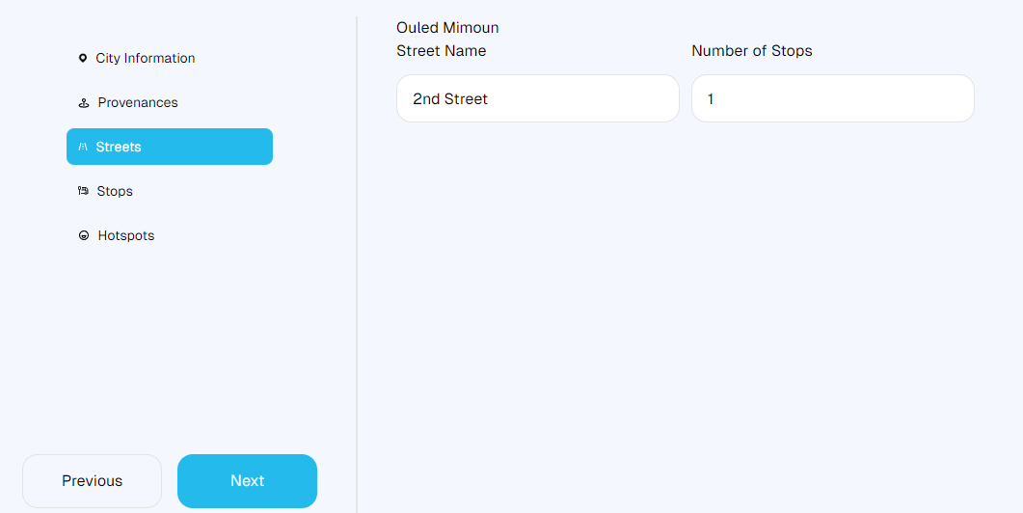
Fig 26. Streets

Depending on the number of streets for every provenance you need to fill in their name and stops count
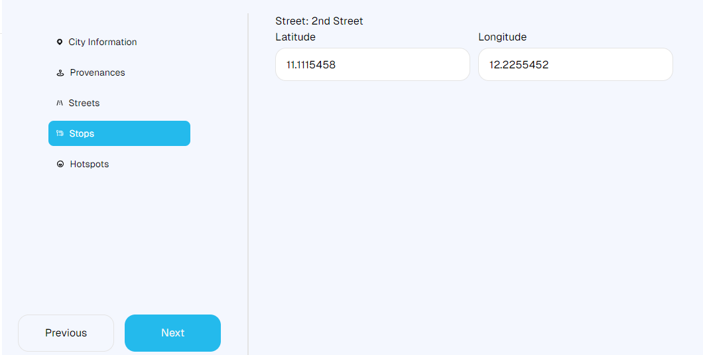
Fig 27. Stops
While the same goes for stops they depend on the number of stops for each street
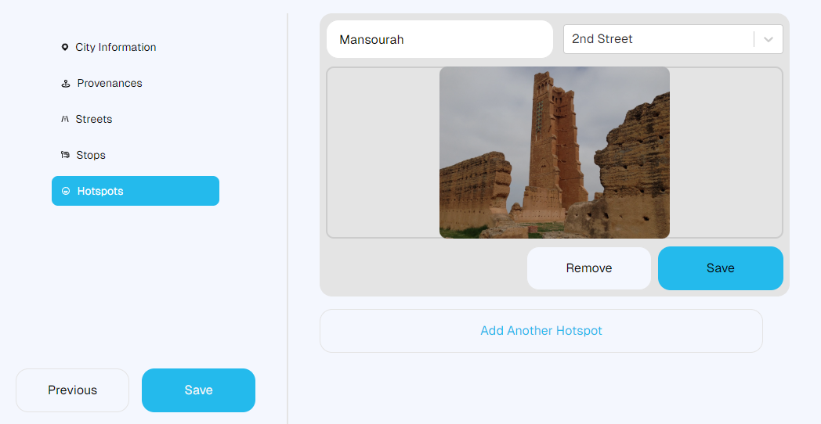
Fig 28. Hotspots
After finishing all the above all that’s left is to add hotspots, they can either historical monuments or frequently visited placed by tourists or the public

- Routes Overview: The Routes overview page shown in figure 29 presents some Statistics about the most popular routes and their number of reservations every day and on the left the number of active buses in total, just right under there is reservations logs where you can each reservation in small details and next to it the pie chart for popular reservation methods
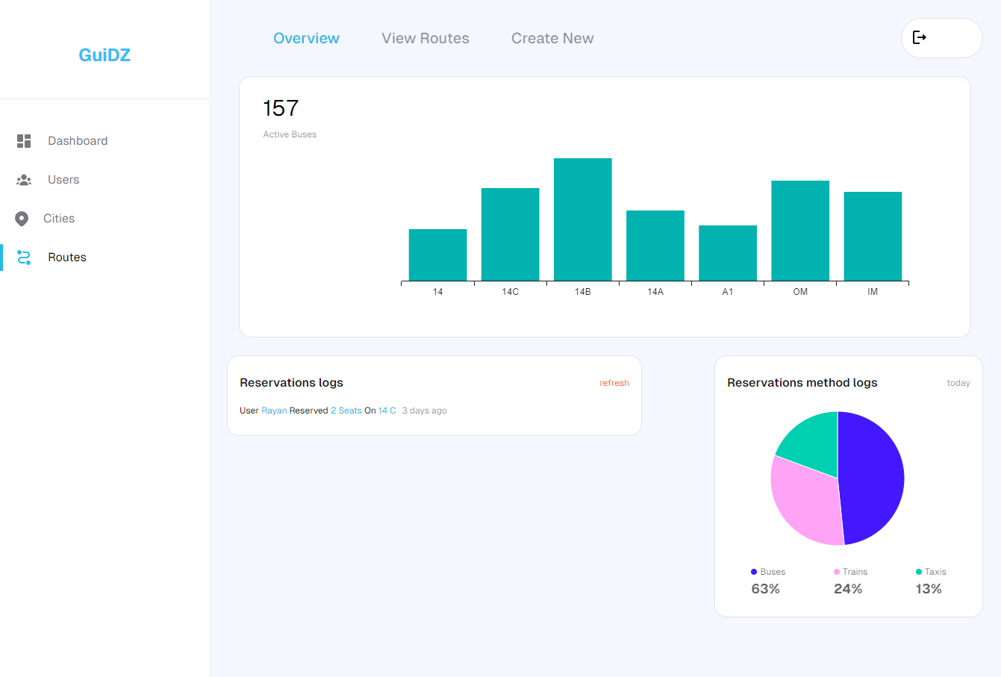
Fig 29. Routes Overview

- View Routes: The view routes page in figure 30 is a table where all the routes and their information are displayed. In order, the route name, stops count, buses count, and state which indicates business. The state can be overflowing, busy, natural, or quiet. From this, the admin can either view, delete, or edit an existing route.
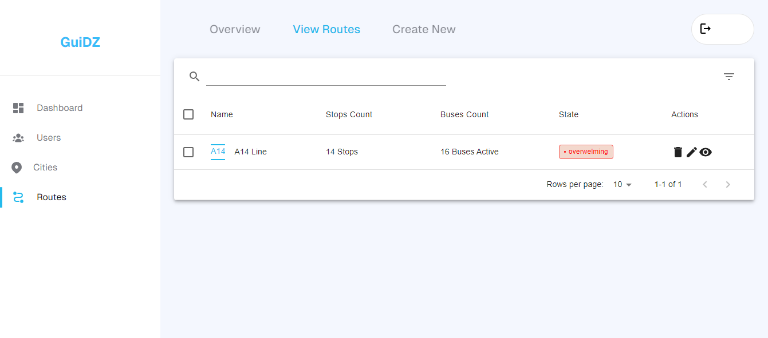
Fig 30. View Routes Table

- New Route: This group of interfaces from figure 31 to figure 36 is how the admin is able to add or edit a route. The route information needs to be filled first which contains the name, city, route type schedule type that could be either scheduled that means it departs at a certain times or rotation which has intervals depending on fast it rotates, then you can add the stops, each with their prices. For each stop, you fill in the time from one stop to another. Lastly, you define the number of seats per bus for the route.
When editing a route, the route information is already there, allowing the admin to make necessary adjustments to the stops, prices, travel times between stops, and the number of seats per bus.
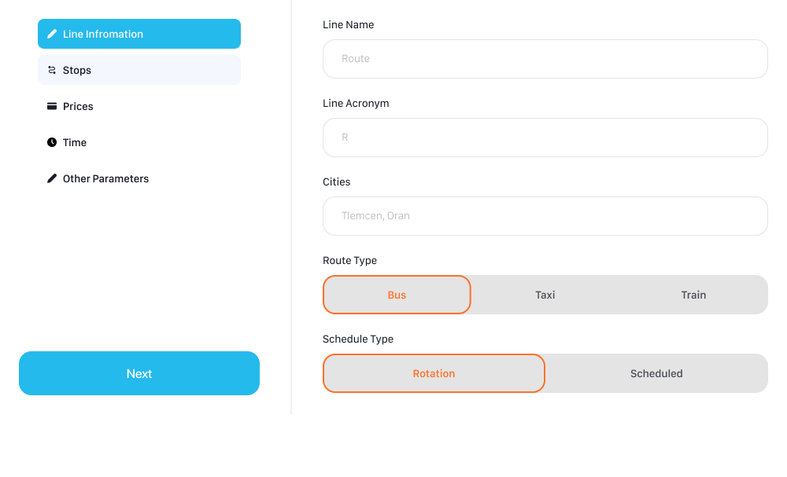
Fig 31. Line Information
The first step in adding a new route is filling the basic information which should be simple
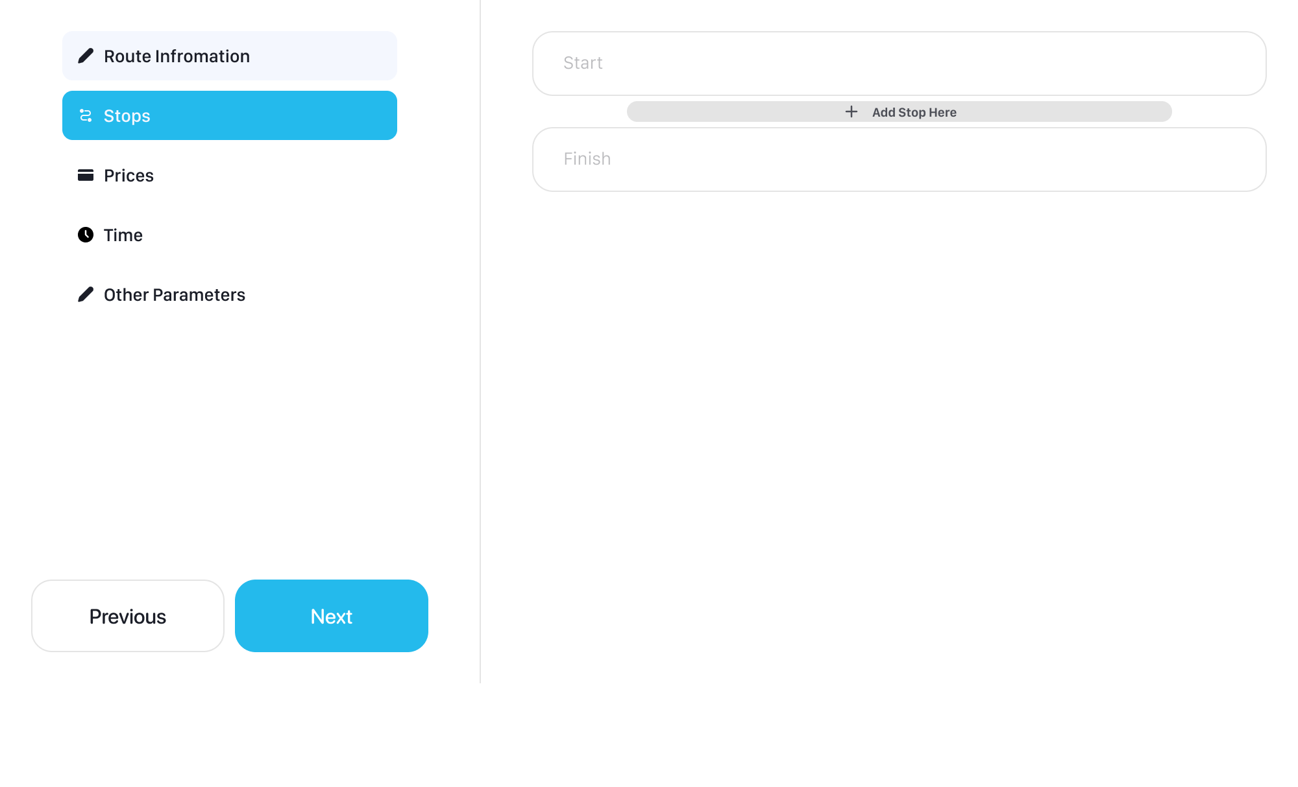
Fig 32. Stops
After filling the line information and selecting a city, all the stops in that city will be available to choose from in this step, its essential to pick the start and finish first then later add stops along the way if needed
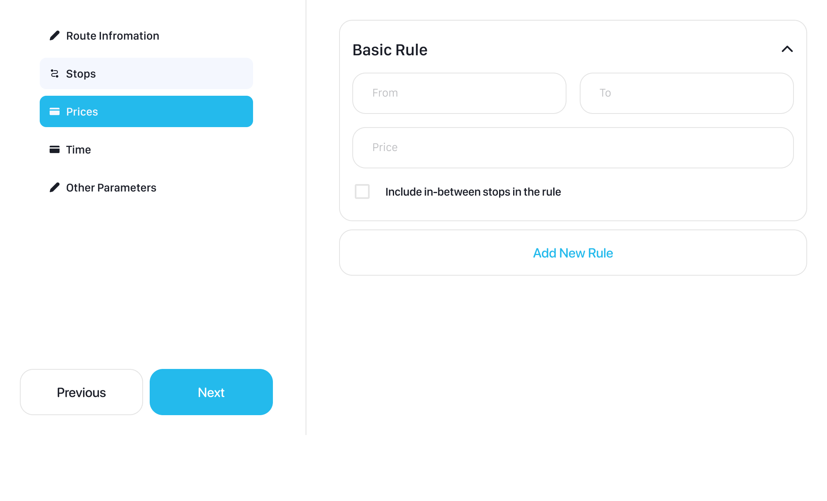
Fig 33. Prices
In the prices section it’s a must to specify at least the price from start to finish of the route and if there are exceptions for other stops in between, it is possible to add them by clicking the add new rule button and adding them
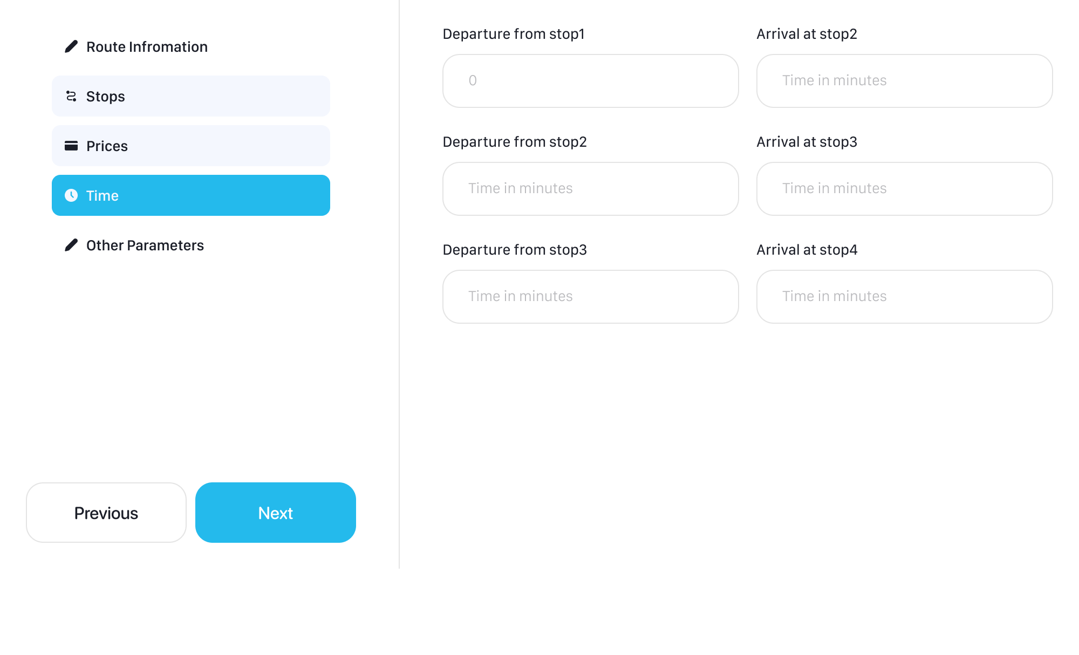
Fig 34. Times
After being done with the prices you must fill out the departure and arrival from stop to another
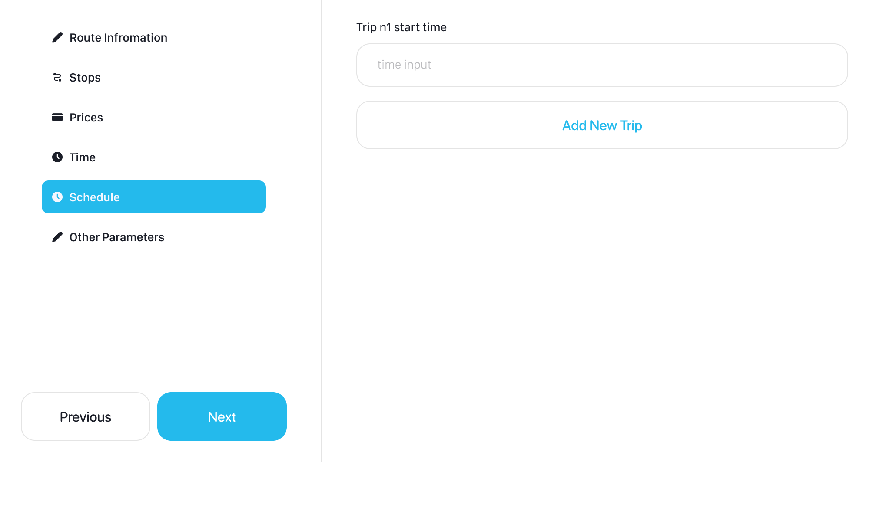
Fig 35. Scheduled And Rotation
Depending on what you choose on the route information, if its scheduled route you need to specify the start time for each trip, else if its rotation you must fill the starting and ending for the rotation and the interval between each trip

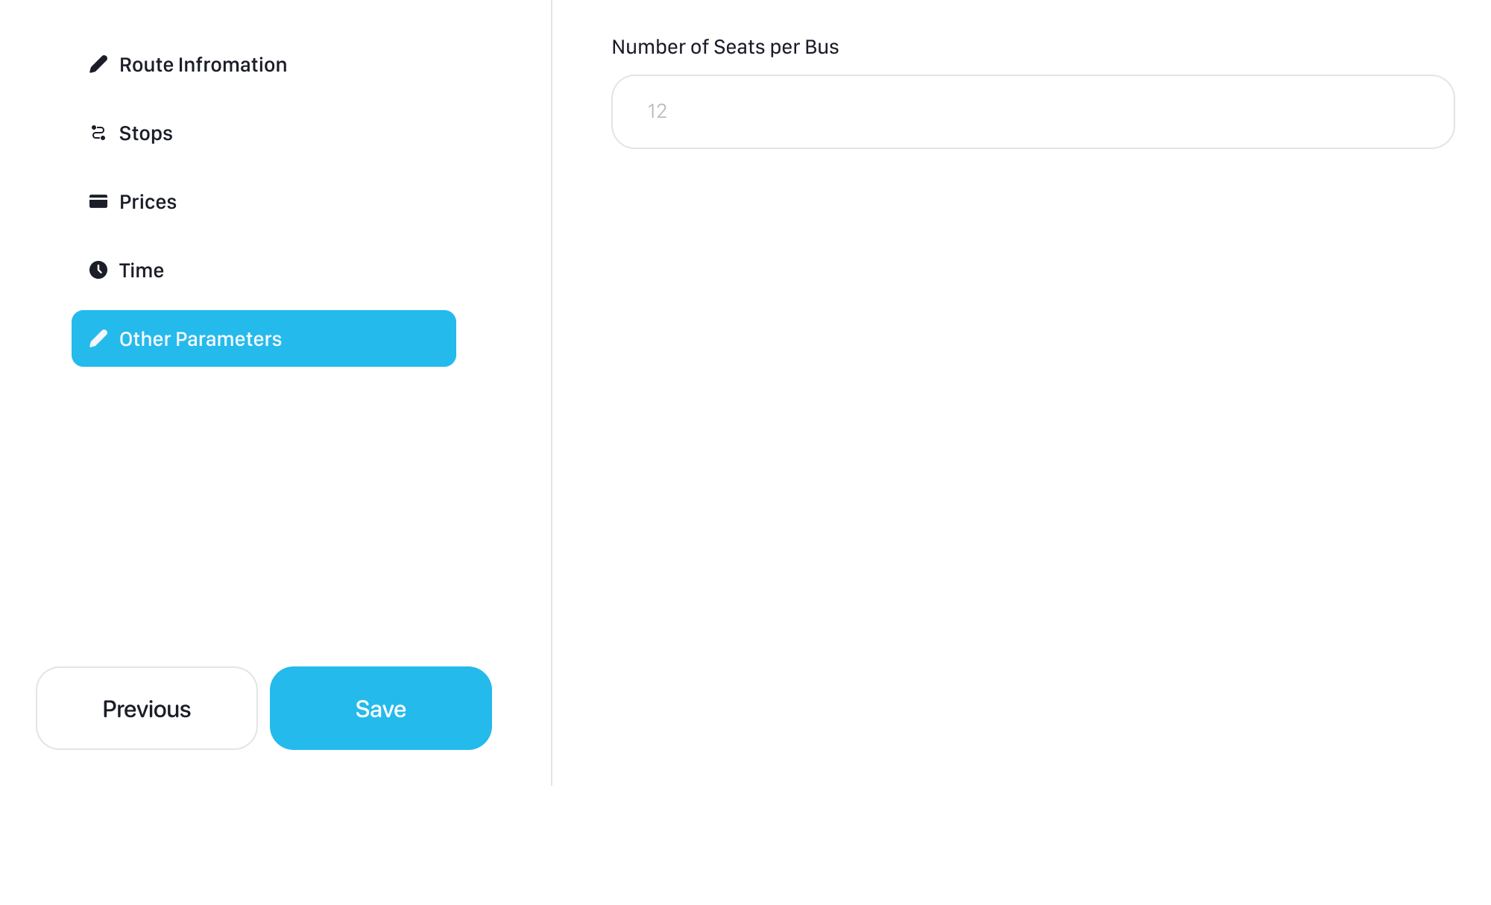
Fig 36. Add New Route Interfaces

Mobile Interfaces:
- Authentication: Bellow in figure 37 we have the multiple interfaces made to authenticate users. Like most applications, ours uses the email and password combination for authentication, with the option to reset your password lays behind the OTP validation wall, users can rest assure that as long as they and only they own the email used for registering, no other bad actors can reach their itineraries
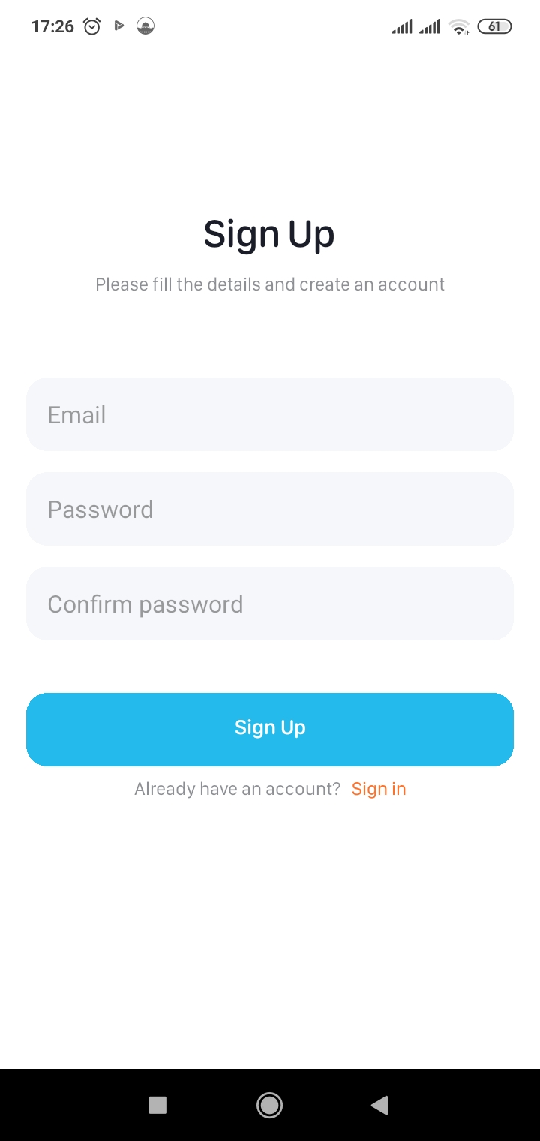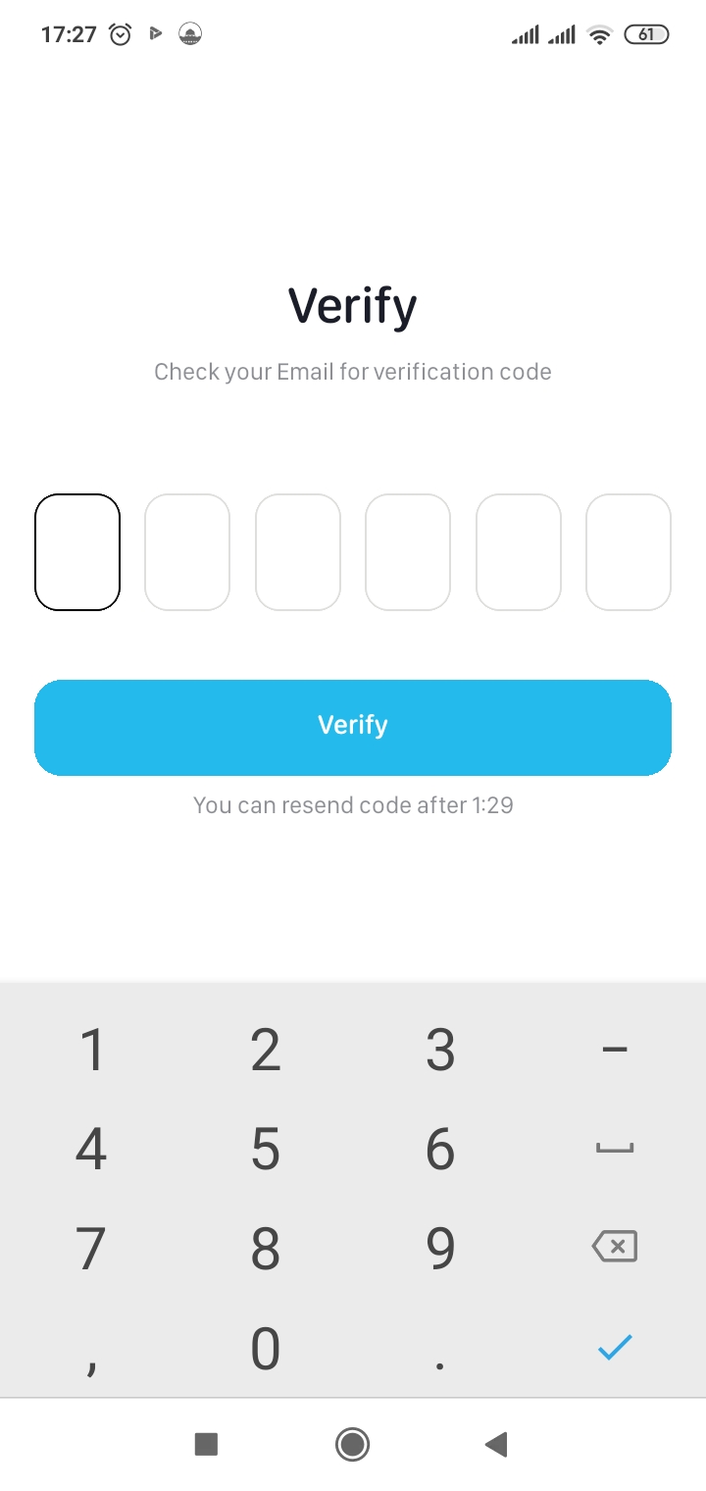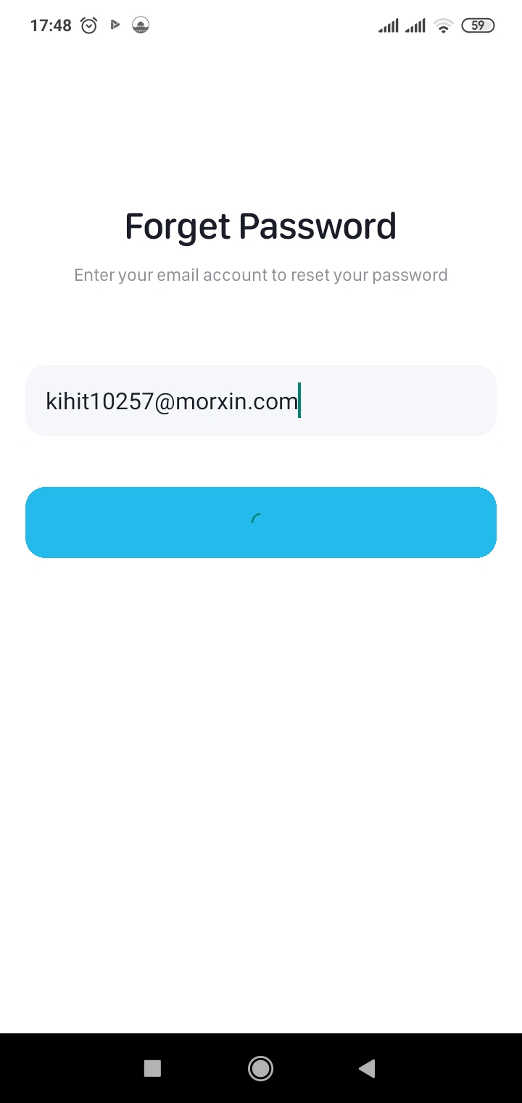
Figs 37. Authentication

- Homepage: Our main application page shown in figure 38 houses the core functionality, enabling users to search for itineraries using various options and fields. The required data includes the departure location (from field) and arrival location (to field), with the number of seats required (set to one by default). Optional inputs include the departure date and time; if left unset, the application defaults to the current date and time.
In addition to the itinerary form fields, we offer Hotspots, representing areas of interest to tourists, from which you can select as your arrival destination.
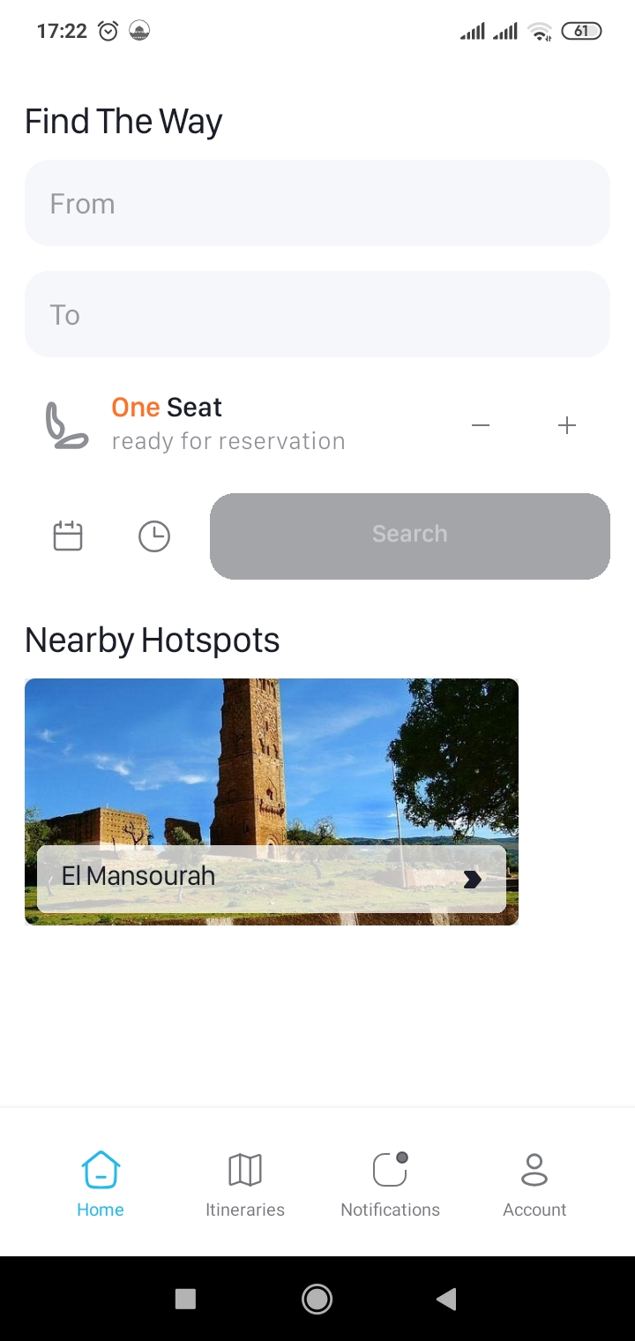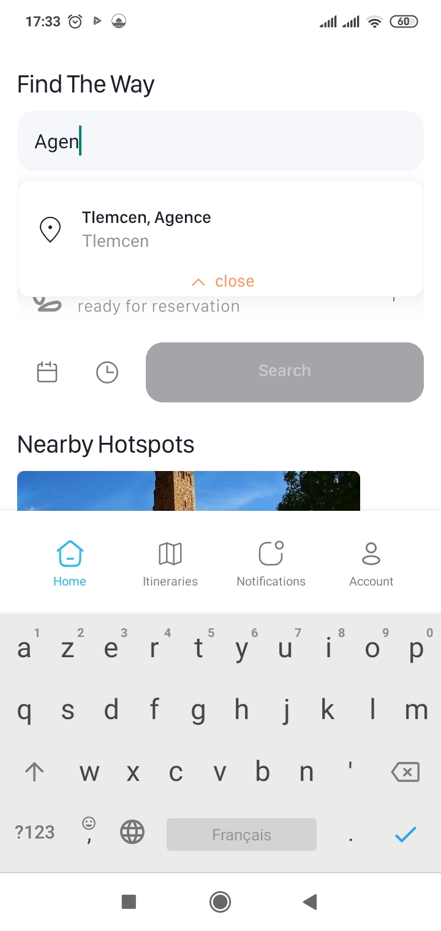
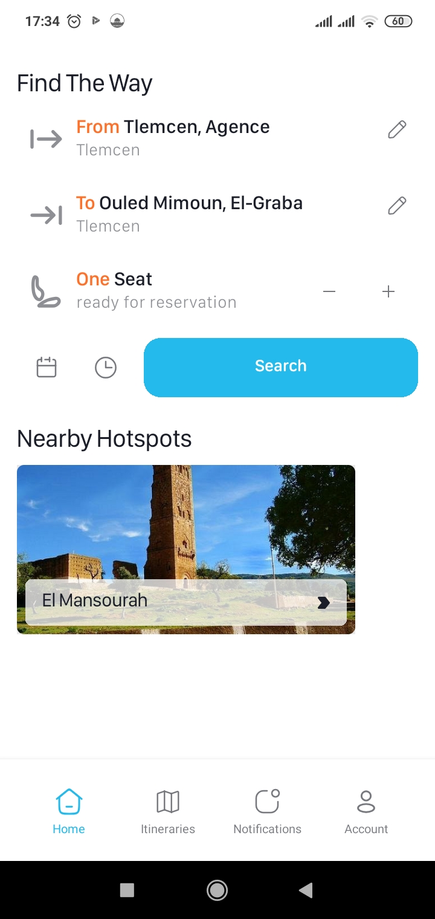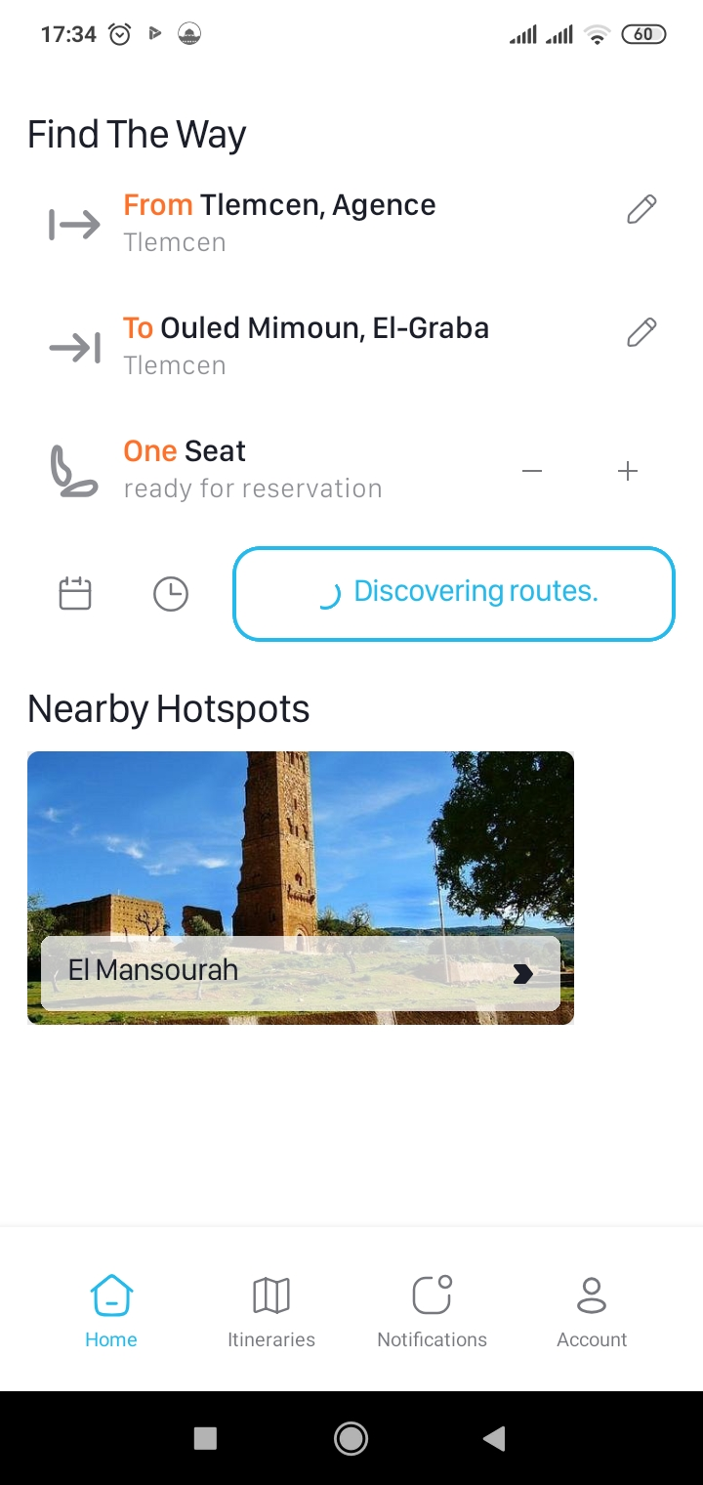
Figs 38. Homepage
On search shown in figure 39, we invoke the modified RAPTOR algorithm through Supabase while keeping track of any resulting errors. Successful invocation displays the results page with the different plans generated.
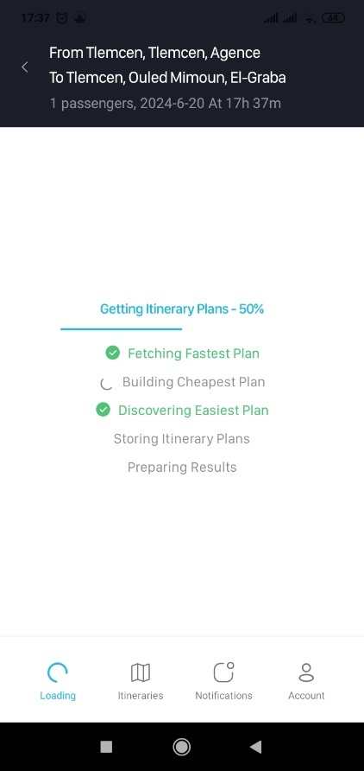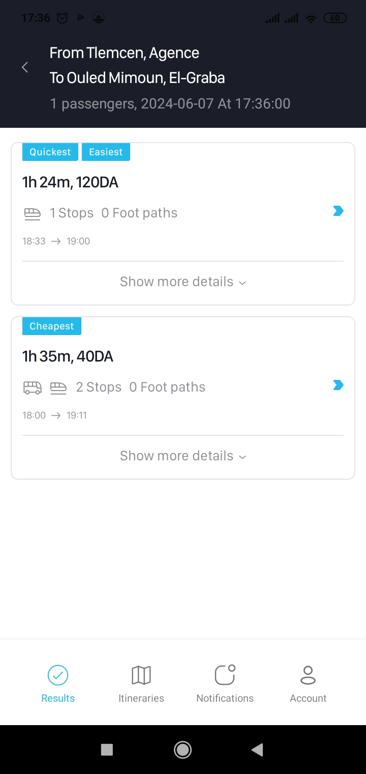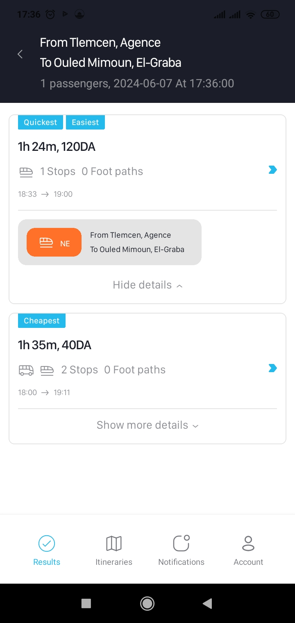
Figs 39. Search Result
Selecting any of the results illustrated in figure 40 shows the plan in details, providing steps and all the necessary information of which you can base your decision.
Once the decision has been made by clicking the select button, the itinerary plan is selected and now you can reserve the number of seats you submitted using your Edahabia card.
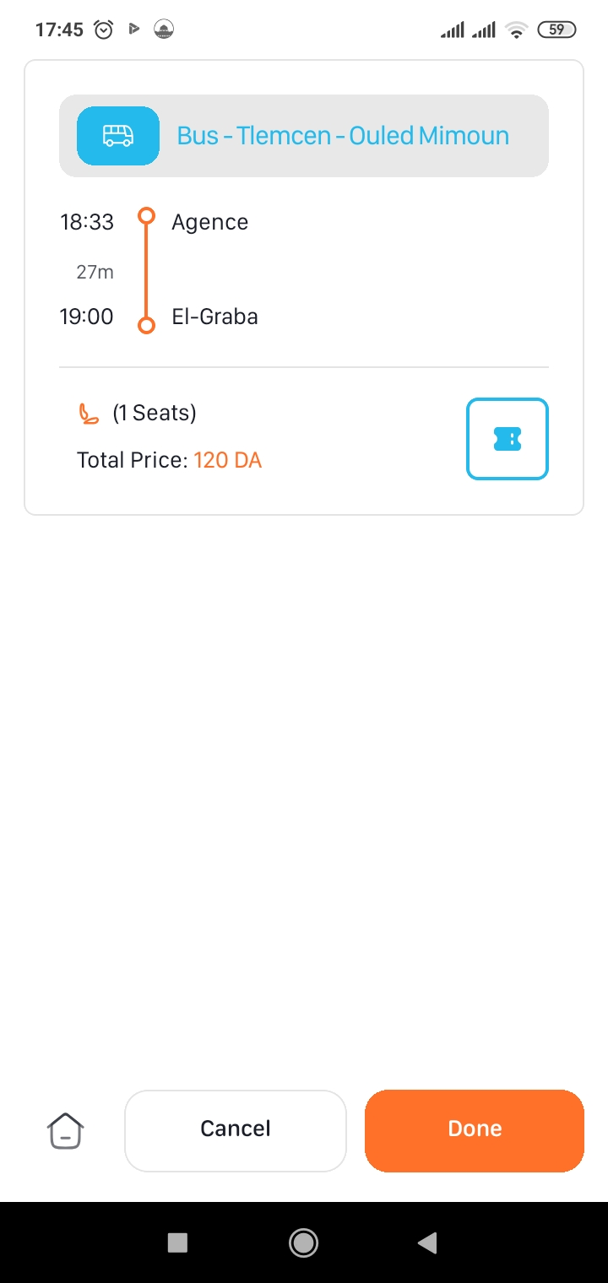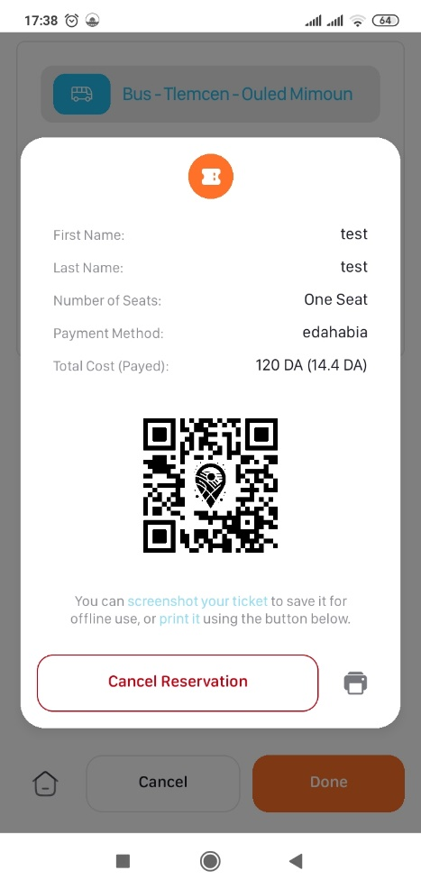
Figs 40. Ticket Reservation
Itineraries: As an authenticated user, you will have access to the homepage button, clicking it will return you back to the homepage from the plan details page, but also saves your itinerary in your on-going tab in itineraries page as show in figure 41. You can access your current itineraries and also your planned ones through that page like so.
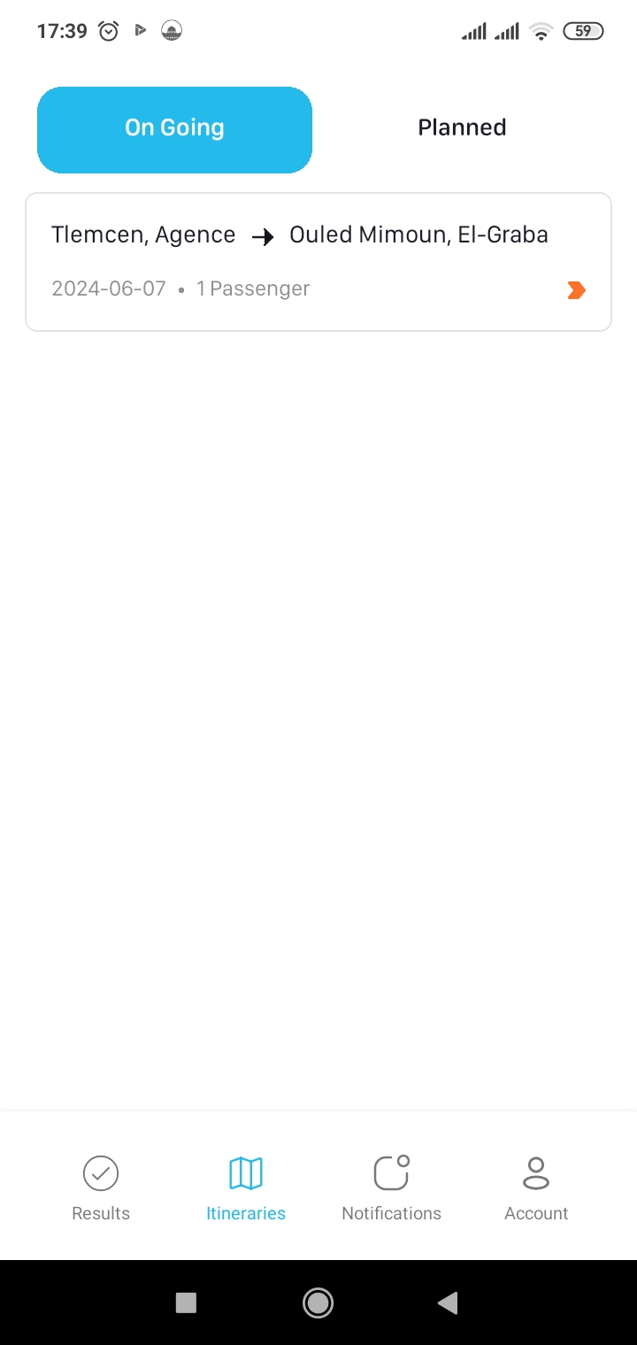
Fig 41. Itineraries

- Account: Also, by the homepage button, there is two buttons, Cancel and Done. Each does its own job but you can get either from the same page in Account > Previous Trips. Also, in the Account page there is Settings, the Upcoming Tickets that we’ve already talked about, Edit Profile, and Log out as all show in figure 42.

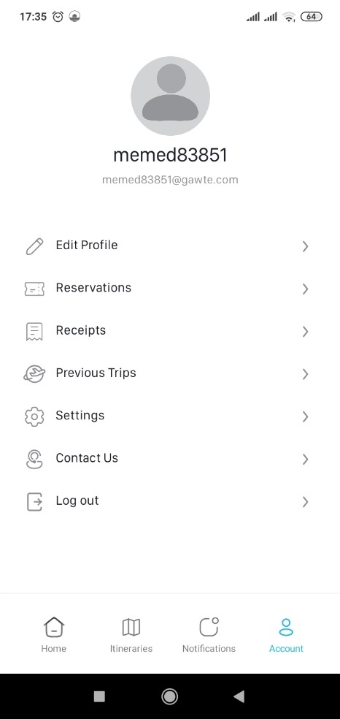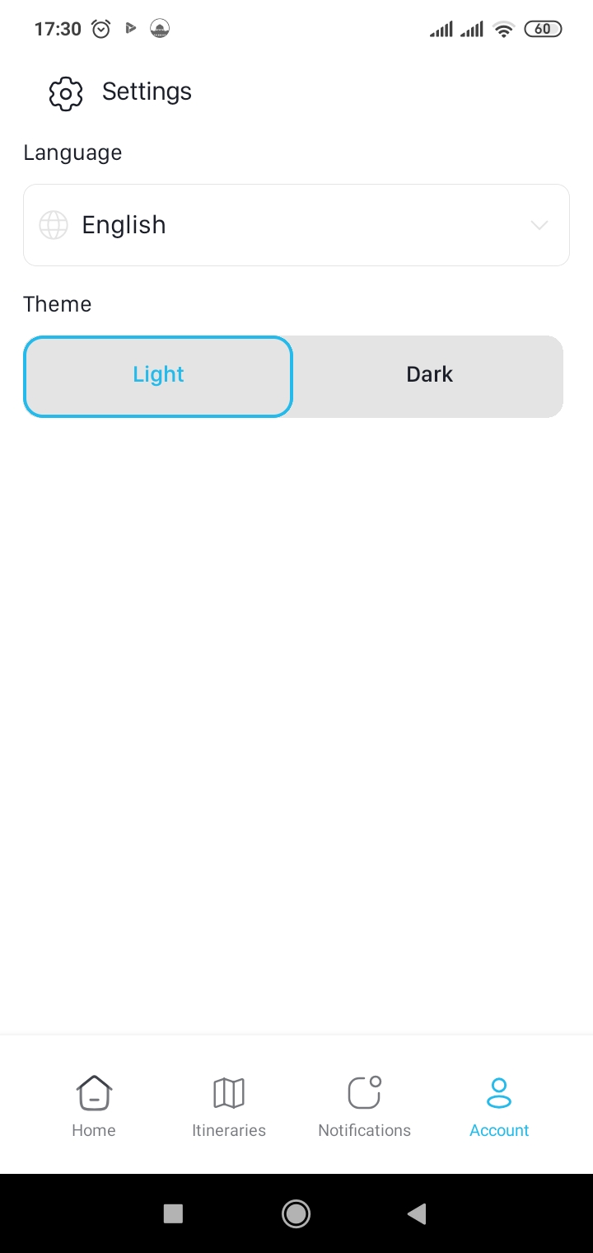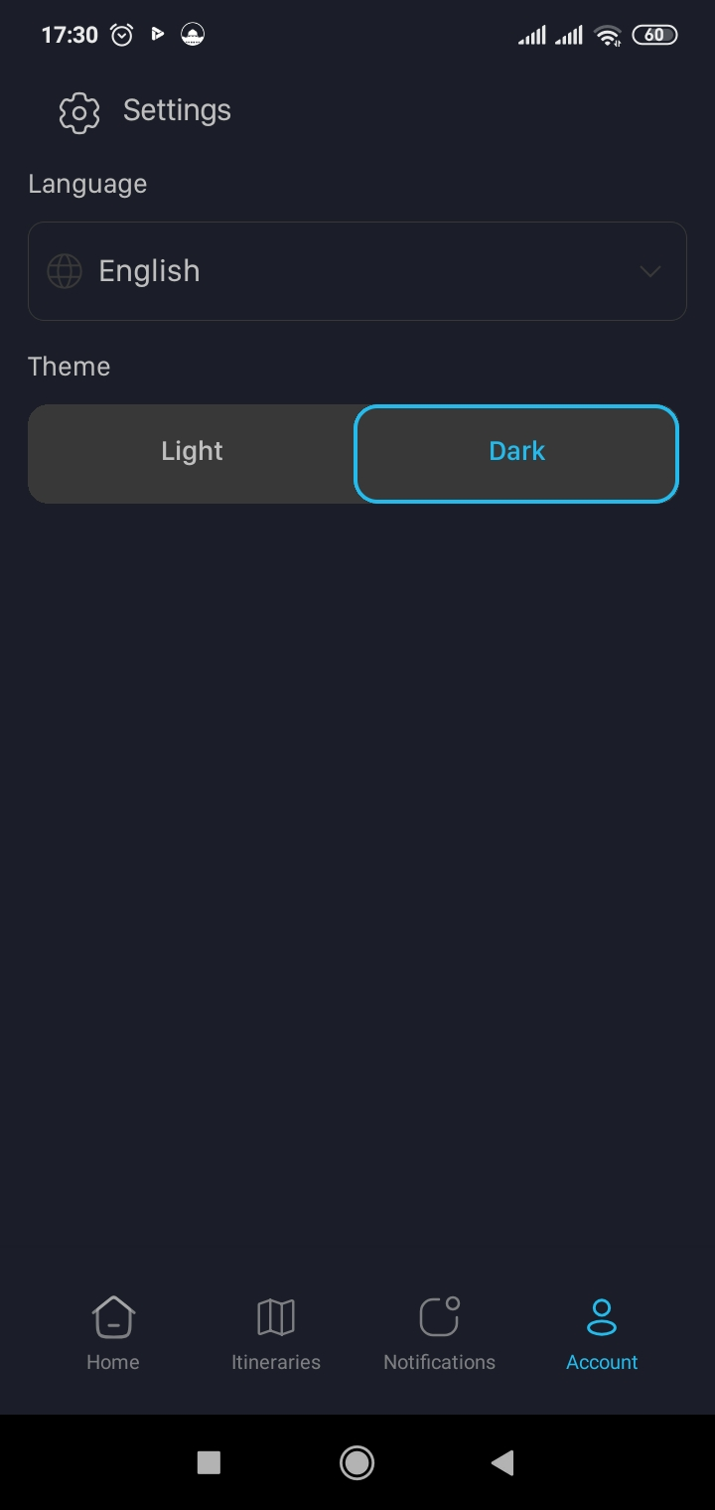
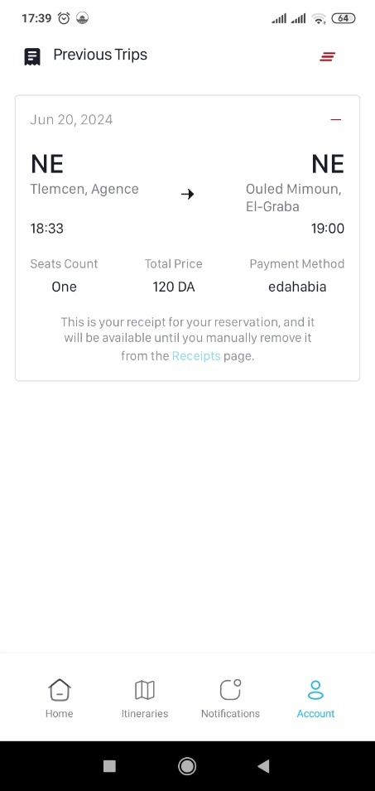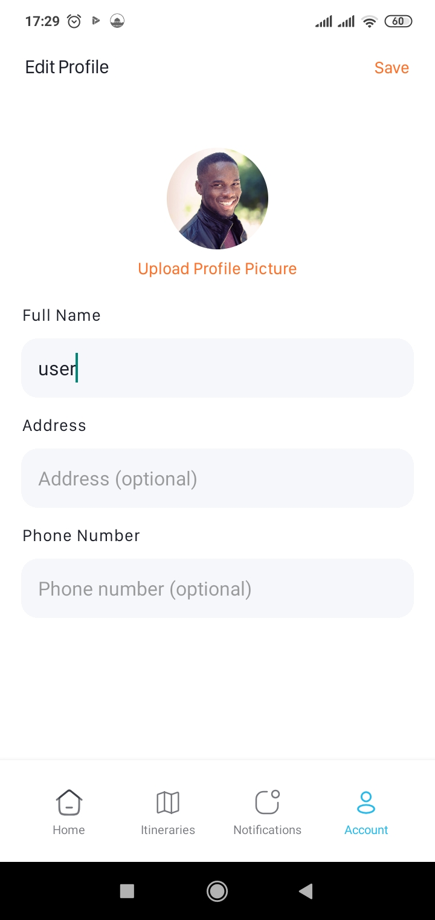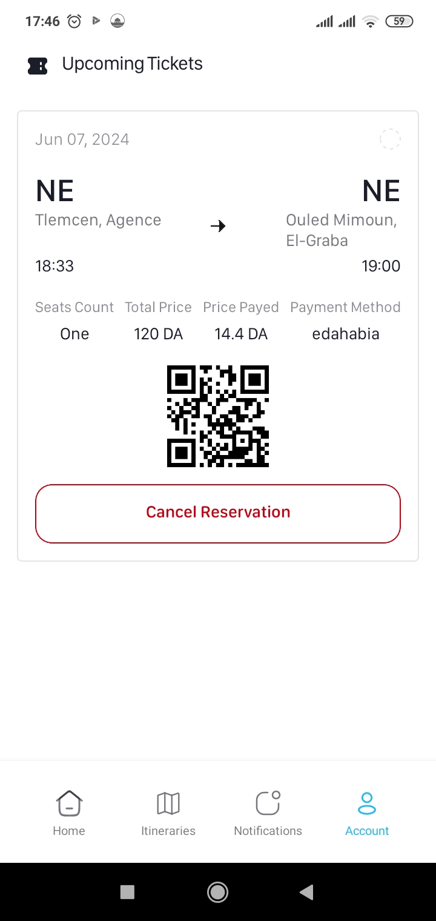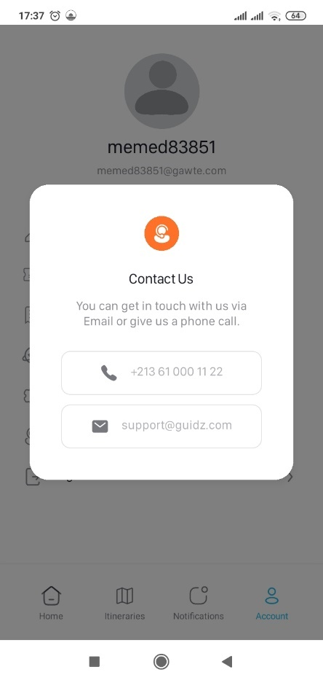
Figs 42. Account
- Notifications: As for the last page on figure 43 to attend to. A dedicated page for notifying authenticated users with their planned trips, missed trips, and missed reservations. All while displaying related actions to take, here is an example of two notification. Missed trip, and planned trip.
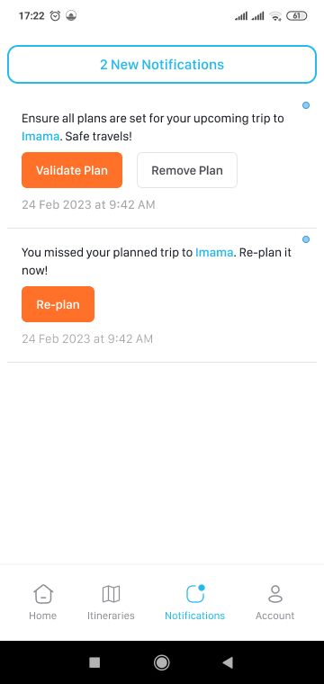
Fig. 43. Notifications
- Conclusion:
This chapter described all the means and technology used for GuiDZ development and deployment, which will be the public transport of better way in Tlemcen. We use many adapted tools to each phase of this development process, from design to implementation. Among the most important tools that were used in this work, we find a graphic design software that allowed us to conceptualize and mock up our application with a purpose so that it would be beautiful and easy to use.
We chose Integrated Development Environments, which best worked with us in our development environment, to offer things like debugging, auto-completion of code, dependency management, among others. They simplified it and increased our rate of development. Programming languages that we used, for example, JavaScript, helped us do robust, maintainable code by applying advanced programming concepts in developing functionalities of our application.
Overall, the technologies and tools we employ helped us to deliver both the mobile application and the web platform. They made it easy to design, develop, and integrate various features in our system with the goal of optimizing the user experience. By using the proper tools, the two applications have been developed that serve to provide good information for citizens and visitors alike, and make Tlemcen's public transportation much more effective and reliable.

GENERAL CONCLUSION
This thesis suggested tackling a, pressing issue of public transportation in the Wilaya of Tlemcen, up streamed mainly due to a lack of information relating to more precise and more updated information on buses, taxis, and trains. With this objective, an integrated information system was proposed for public transport that would update in real-time, have updated route maps, and easily accessible time-schedules through mobile applications and websites.
GuiDZ is an ultimate integrated solution to Tlemcen's problem of urban mobility. By providing real-time information via simple and clear interfaces, which is the outcome of reliable data, our system will encourage the use of public transports that will render the city more accessible to people and greener. This project can be considered a good example of the part technology can play in urban transport issues resolution and as a prelude to various further developments elsewhere.
In short, the service will generally strive to make public transportation in Tlemcen better and more efficient. It is going to save people a lot of time. In addition, it might reduce traffic and pollution by encouraging people to use public transportation instead of their cars.
- Perspective:
- We aim to expand 'Guidz' beyond the Wilaya of Tlemcen to other regions
- We plan to integrate 'Guidz' with other existing transport systems and services, offering a seamless experience for users
- We intend to enhance the application by adding real-time support features like instant updates on schedules, and live support for users needing assistance during their travel

Bibliography:
- DzairTransport, https://www.dzairtransport.com/, 16/03/2024
- DzairTransport, play store, https://play.google.com/store/apps/details?id=com.dzairtransport&hl=en&pli=1, 16/03/2024
- Sogral, https://www.sogral.dz/index.php/fr/, 16/03/2024
- MAHATATI, play store, https://play.google.com/store/apps/details?id=com.sogral.mobile&hl=en, 16/03/2024
- Citymapper, https://citymapper.com/?lang=en, 16/03/2024
- Citymapper, play store, https://play.google.com/store/apps/details?id=com.citymapper.app.release&hl=en&gl=US, 16/03/204
- SNCF Connect, https://www.sncf-connect.com/en-en/, 19/03/2024
- ISO 9241-11:1998(E). "Ergonomic requirements for office work with visual display terminals (VDTs) — Part 11: Guidance on usability." International Organization for Standardization.
- ISO/IEC 25010:2011. "Systems and software engineering -- Systems and software Quality Requirements and Evaluation (SQuaRE) -- System and software quality models." International Organization for Standardization.
- Fowler, Martin; Scott, Kendall (1997). "UML Distilled: A Brief Guide to the Standard Object Modeling Language". Addison-Wesley. ISBN 0-201-32563-2.
- Ambler, S. W. (2003). "The Elements of UML 2.0 Style". Cambridge University Press. ISBN 978-0-521-54018-6.
- Booch, G., Rumbaugh, J., & Jacobson, I. (2005). "Unified Modeling Language User Guide, The (2nd Edition)." Addison-Wesley Professional.
- React Docs, https://reactjs.org/docs/getting-started.html, 25/05/2024
- React Native, https://reactnative.dev/docs/getting-started, 25/05/2024
- NextJS, https://nextjs.org/, 25/05/2024
- Deno Docs, https://deno.land/manual, 25/05/2024
- Tailwind CSS, https://tailwindcss.com/docs, 25/05/2024
- PostgreSQL, https://www.postgresql.org/, 25/05/2024
- Visual Studio Code, https://code.visualstudio.com/docs, 26/05/2024
- Project IDX, https://developers.google.com/idx/guides, 26/05/2024
- Expo, https://docs.expo.dev/core-concepts/, 26/05/2024
- Expo Go, https://docs.expo.dev/, 26/05/2024
- Supabase, https://supabase.com/, 26/05/2024
- Figma, https://www.figma.com/, 26/05/2024
- Docker Docs, https://docs.docker.com/, 26/05/2024
- Nox, https://www.bignox.com/, 26/05/2024
- LucidChart, https://www.lucidchart.com/pages/, 26/05/2024
- GitHub, https://docs.github.com/en, 26/05/2024
- Delling, D., Pajor, T., & Werneck, R. F. (2015). Round-based public transit routing. Transportation Science, 49(3), 591-604.

Abstract:
The wilaya of Tlemcen does not allow efficient use of public transport this results from the use of old paper systems and inaccuracy of information. The objective of our work is to develop a mobile application for public transport management that we named “GUIDE DZ” which would allow residents to move around the wilaya of Tlemcen easily without wasting time and reducing travel times. waiting. Visitors would benefit from an easy-to-access, friendly service that would promote location during visits. Our application also has economic value, it improves the level of public transport, which would guarantee better access to mobility for local businesses and attract investment and development projects.

ملخص:
ولاية تلمسان لا تسمح بالاستخدام الفعال لوسائل النقل العام وهذا ناتج عن استخدام الأنظمة الورقية القديمة وعدم دقة المعلومات. الهدف من عملنا هو تطوير تطبيق للهاتف المحمول لإدارة النقل العام أطلقنا عليه اسم "GUIDE DZ" والذي من شأنه أن يسمح للمقيمين بالتنقل في ولاية تلمسان بسهولة دون إضاعة الوقت وتقليل أوقات الانتظار. سيستفيد الزوار من خدمة ودية يسهل الوصول إليها والتي من شأنها تعزيز الموقع أثناء الزيارات. يتمتع تطبيقنا أيضًا بقيمة اقتصادية، فهو يعمل على تحسين مستوى النقل العام، مما يضمن وصولاً أفضل إلى التنقل للشركات المحلية وجذب المشاريع الاستثمارية والتنموية.
.

Résumé :
La wilaya de Tlemcen ne permet pas une utilisation efficace des transports en commun cela résulte de l'utilisation d'anciens systèmes sur papier et de l'inexactitude des informations. L’objectif de notre travail est de développer une application mobile de gestion des transports en communs que nous avons nommé « GUIDE DZ » qui permettrait aux habitants de se déplacer dans la wilaya de Tlemcen facilement sans perdre de temps et en réduisant les temps d'attente. Les visiteurs bénéficieraient d'un service facile d'accès et convivial qui favoriserait l'emplacement pendant visites. Notre application a également une valeur économique, elle améliore le niveau de transport public, ce qui garantirait un meilleur accès à la mobilité aux entreprises locales et attirerait des projets d'investissement et de développement.

